**Project-1:**

**Deploying the website on AWS EC2 Instance**

**Create Virtual Private Cloud(VPC)**

Steps :

1. In AWS console, search VPC.

2. In VPC dashboard , you will get my VPC’s and click on myvpc’s.

3. Click on create VPC. Select resource to create as vpc only.

4. Give name as anvitha-vpc and IPv4 CIDR as 10.0.0.0/16.

5. Then click on create VPC.

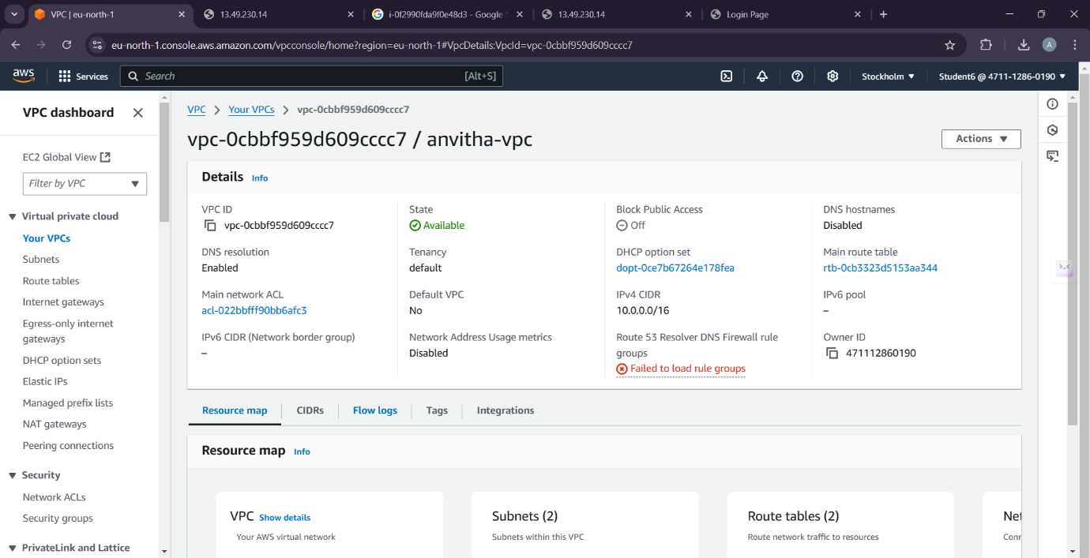

**Create Internet Gateway(IGW)**

Steps :

1. In VPC dashboard, click on Internet Gateway.

2. To create Internet gateway, click on create Internet Gateway.

3. Then give name as anvitha-igw and click on create Internet Gateway.

4. Your internet Gateway is created

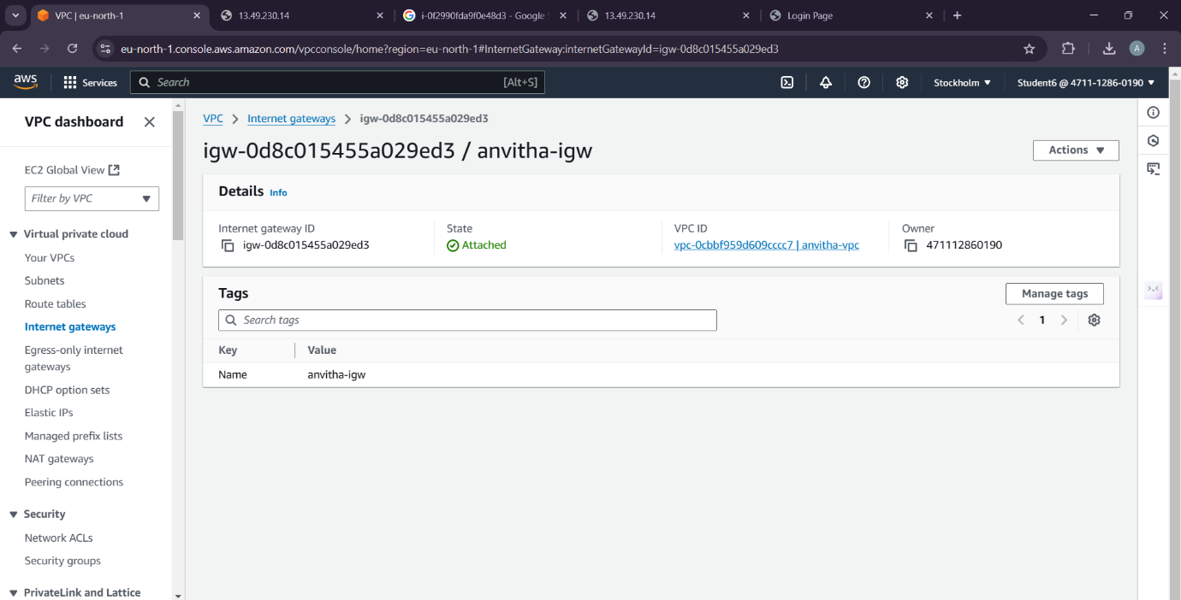

**Create Public Subnet-1:**

Steps :

1. To create subnet, go to VPC dashboard under virtual private cloud, click on subnet.

2. Select the vpc you have already created and in subnet setting, give subnet name as public-subnet-01 .

3. Then choose availability zone as region you have selected before creating the vpc and IPv4 subnet CIDR block as 10.0.1.0/24.

4. Then create one more subnet as following subnet but give name as publicsubnet-02 and then choose availability zone and IPv4 subnet CIDR block as 10.0.2.0/24

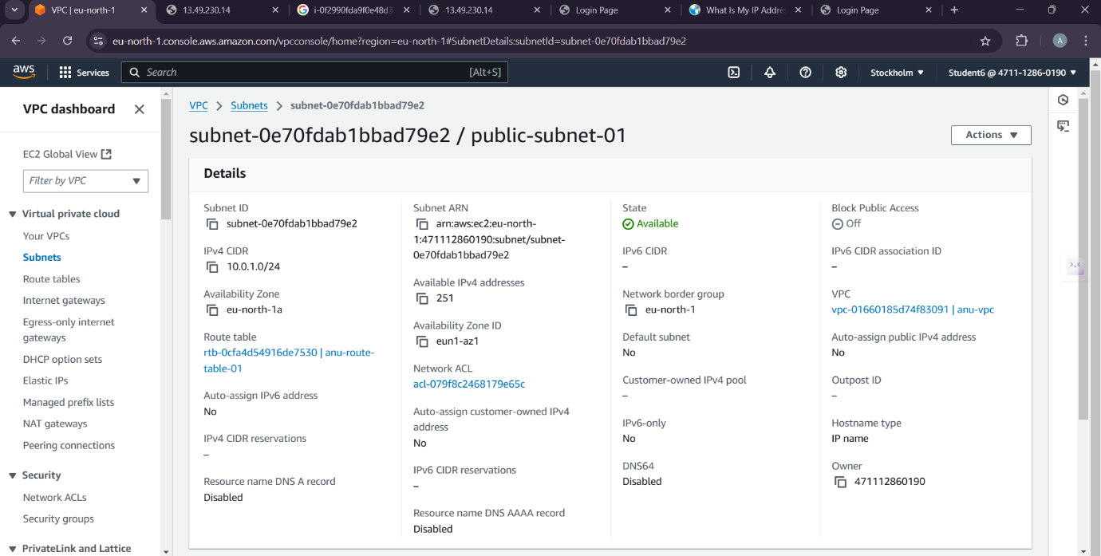

**Create Public Subnet-2:**

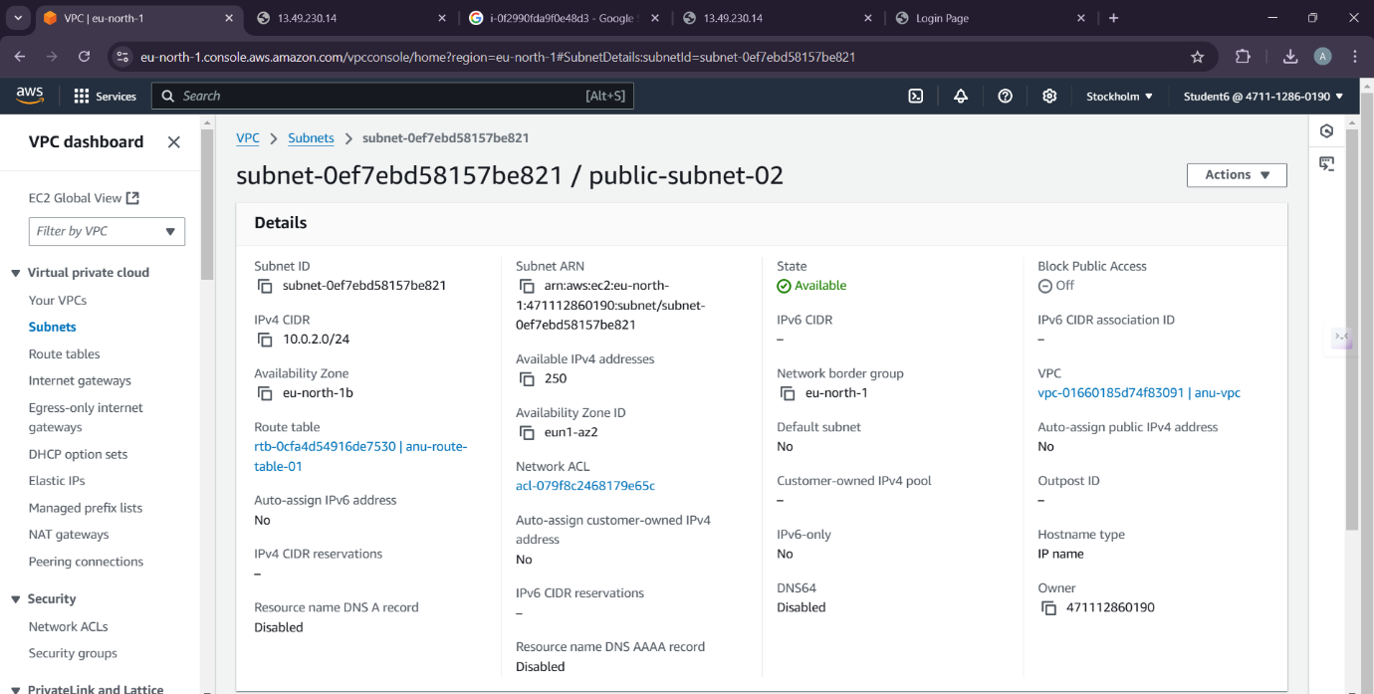

**Create Route Table:**

Steps :

1. To create Route table, click on create route table.

2. In route table setting, give route table name as pubanvitha-rt and select vpc that is created

3. Then click on create route table.

4. After route table is created, go to routes and click on edit route and then click on add route.

5. Then in destination, select 0.0.0.0/0 as destination and target as Internet Gateways .

6. After selecting internet gateway, it allows to select the igw- and select the internet gateway that is created by you.

7. At last click on save changes.

8. Then go to subnet association and click on edit subnet association.

9. Select the subnet you have created and click on save changes.

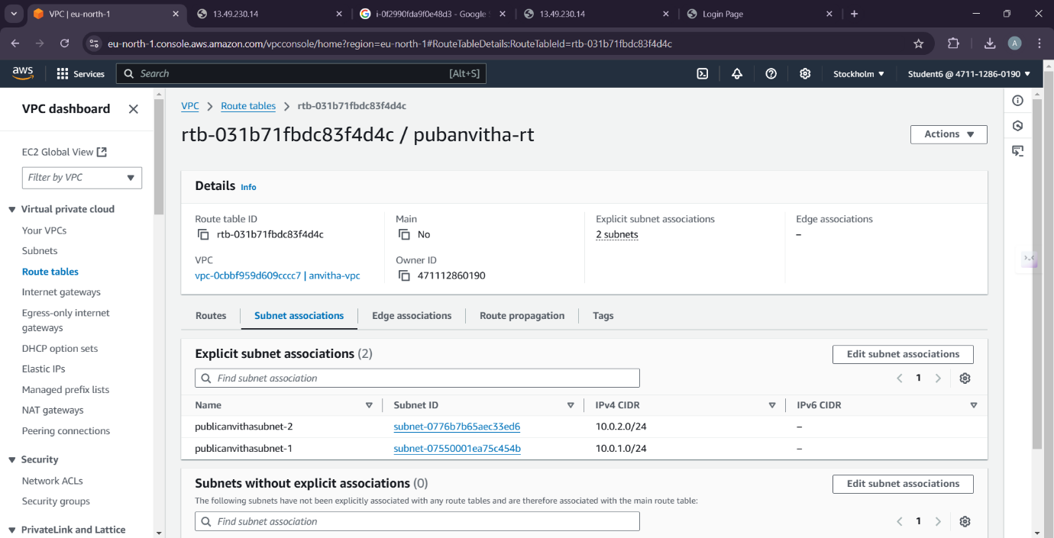

**EC2 Instance:**

Steps:

1. Go to EC2 in AWS console and click on instances.

2. Click on launch instance and give the name for the instances as anuserver.

3. After giving name to instances, select application and OS Images as Amazon Linux and instances type as t2.micro .

4. In keypair, click on create keypair and give keypair name as anu-keypair and click on create keypair. The keypair is created

5. Then in network setting, click edit. Select vpc and subnet and also assign public IP as enable.

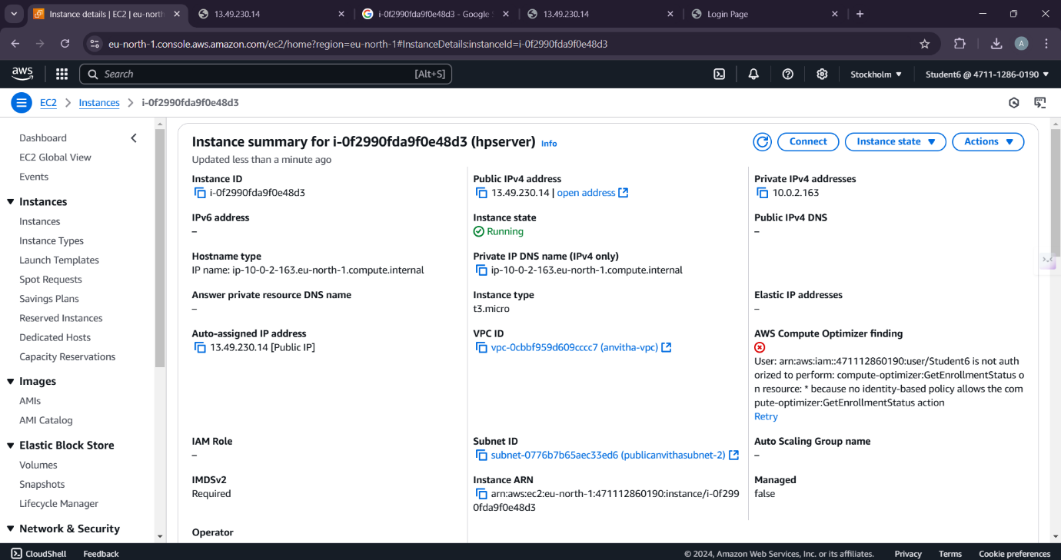

**Connection:**

1.Connect to Instance in SSH Client

2.Copy the ssh and paste in the command prompt

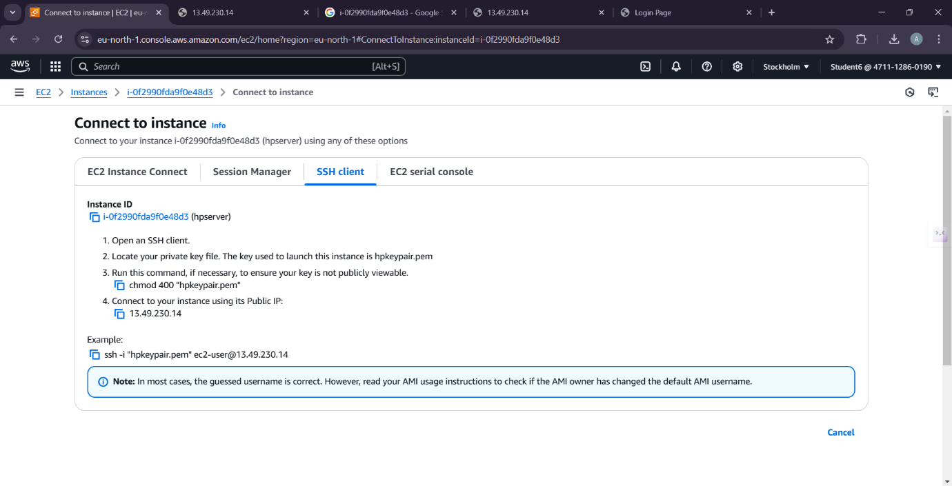

Command Prompt:

Open the command prompt and provide the following commands

1. cd downloads

2. ssh -i "hp-keypair.pem" ec2-user@13.49.230.14.

3.sudo su

4. cd

5. yum install httpd –y

6. cd /var/www/html

7. vi index.html Provide the appropriate code

8. cat index.html

9. systemctl start httpd

10. systemctl enable httpd

11. systemctl status httpd

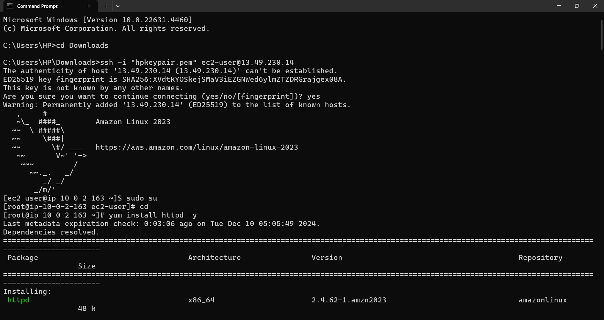

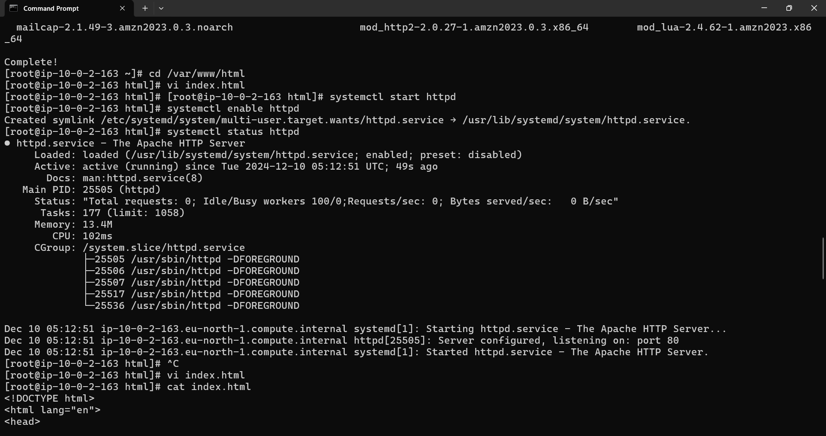

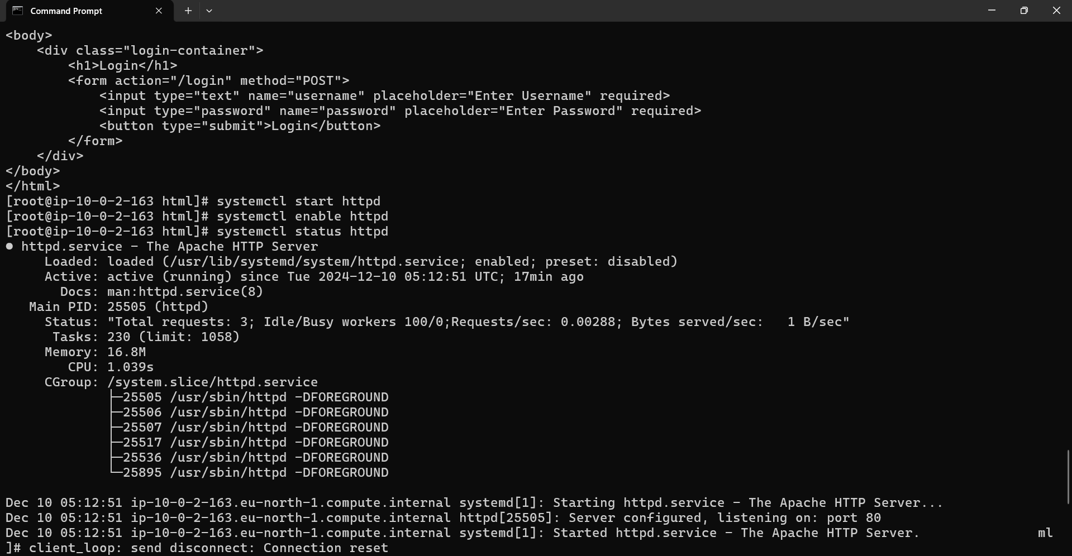

**Final Result:**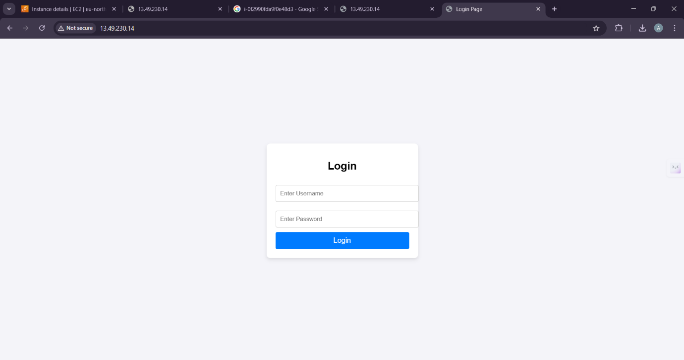

**Project-2:**

**How to create the new EC2 instance by using Amazone Machine Images(AMI)**

**Creating Image:**

Steps

1. Under the EC2 dashboard, select instances

2. Check the anvitha-server. Under Actions drop down button select Images and templets and then select create image.

3. Provide the image name and description as anvitha-backup-server.

4. Click the create image button.

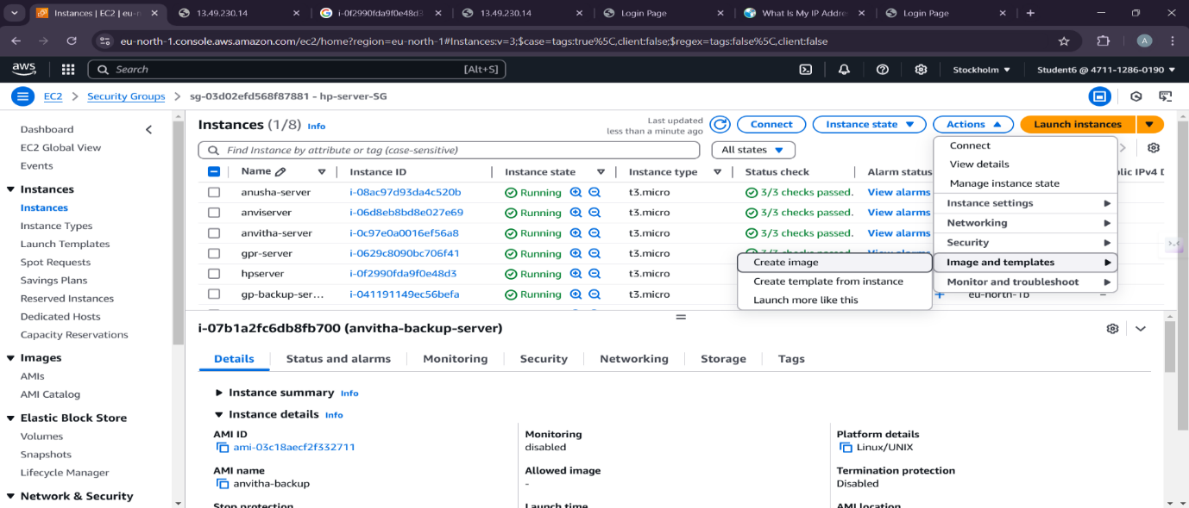

**AMI Summary:** 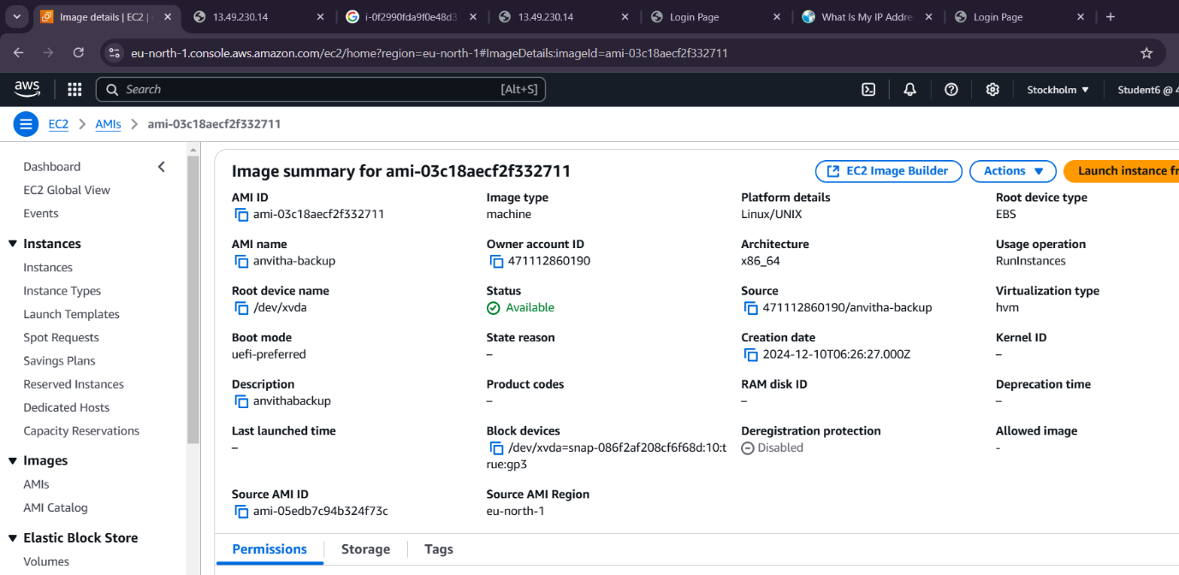

**After launching the backup server**

Steps

1. In the EC2 dashboard, select AMI under Images

2. Check the anvitha-backup-server, click the Launch instance from AMI.

3. Provide the name as sai-backup-server.

4. Provide the instance type as t2.micro and provide the VPC created.

5. Under network setting enable auto assign IP- address and select the existing security group. 6. Launch the activity.

7. Copy the Private IPv4 addresses from the instance summary and paste it in the browser

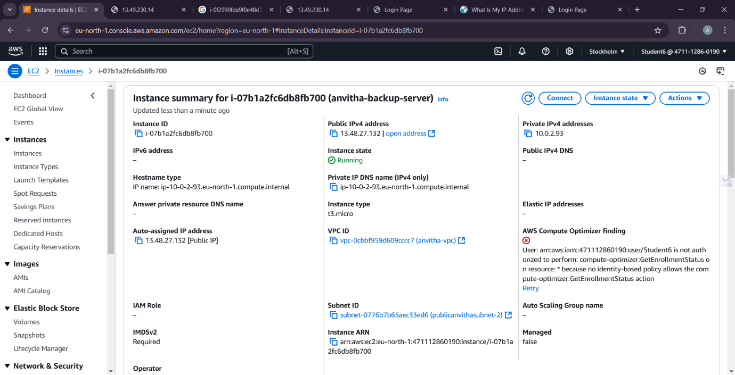

**Result:**

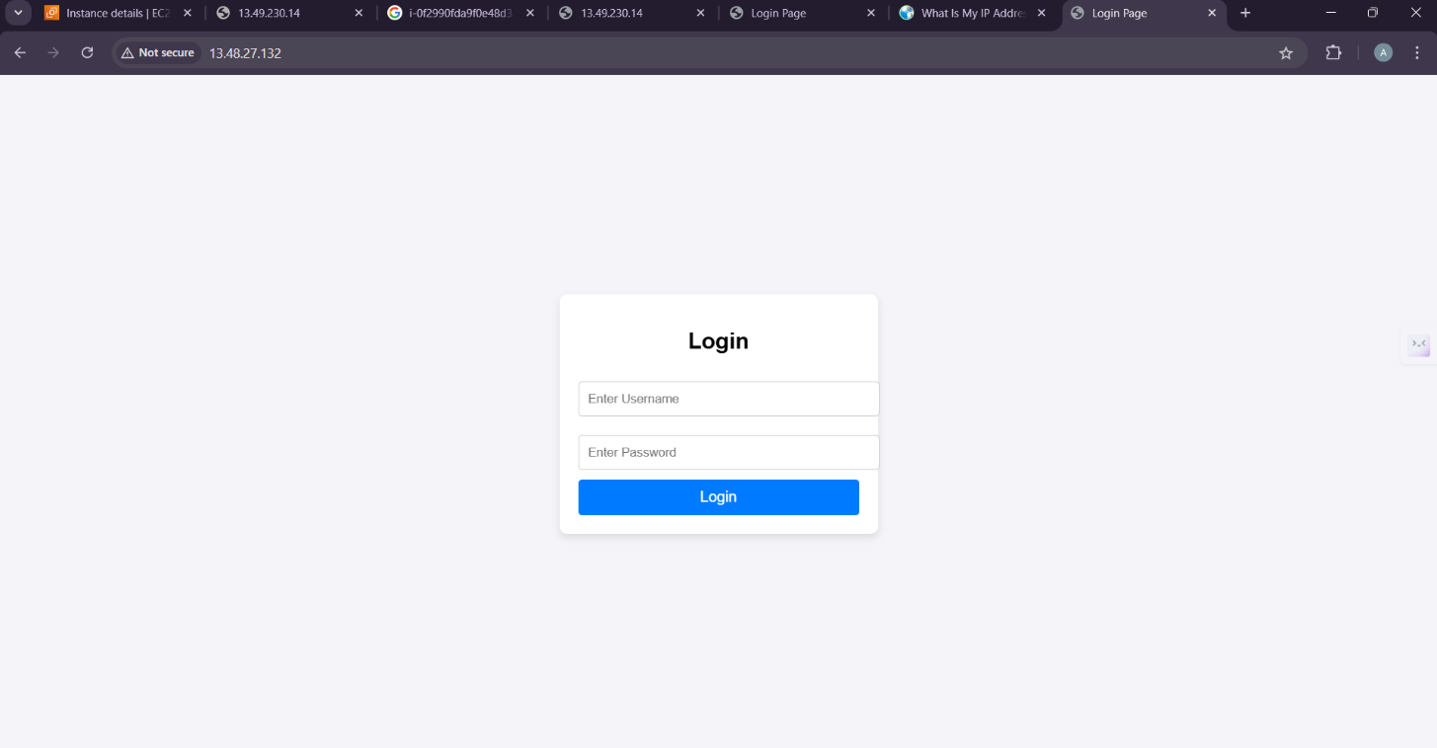

**Project 3:**

**How to connect the private server to the internet using the nat**

**Gateway(Jump server/Bastion host)**

**1)Virtual Private Cloud (VPC):**

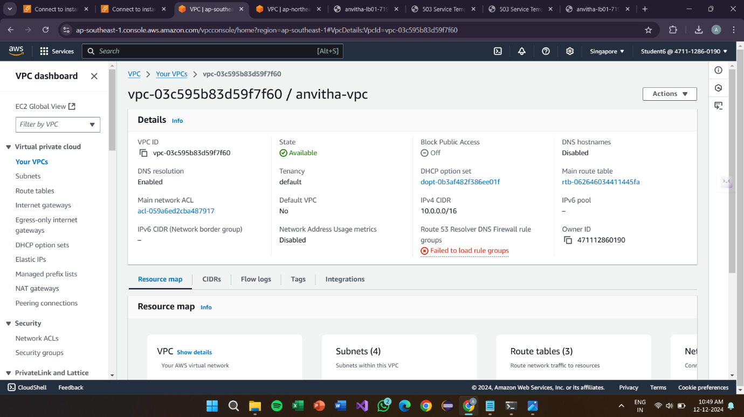

**Internet Gatewauy:**

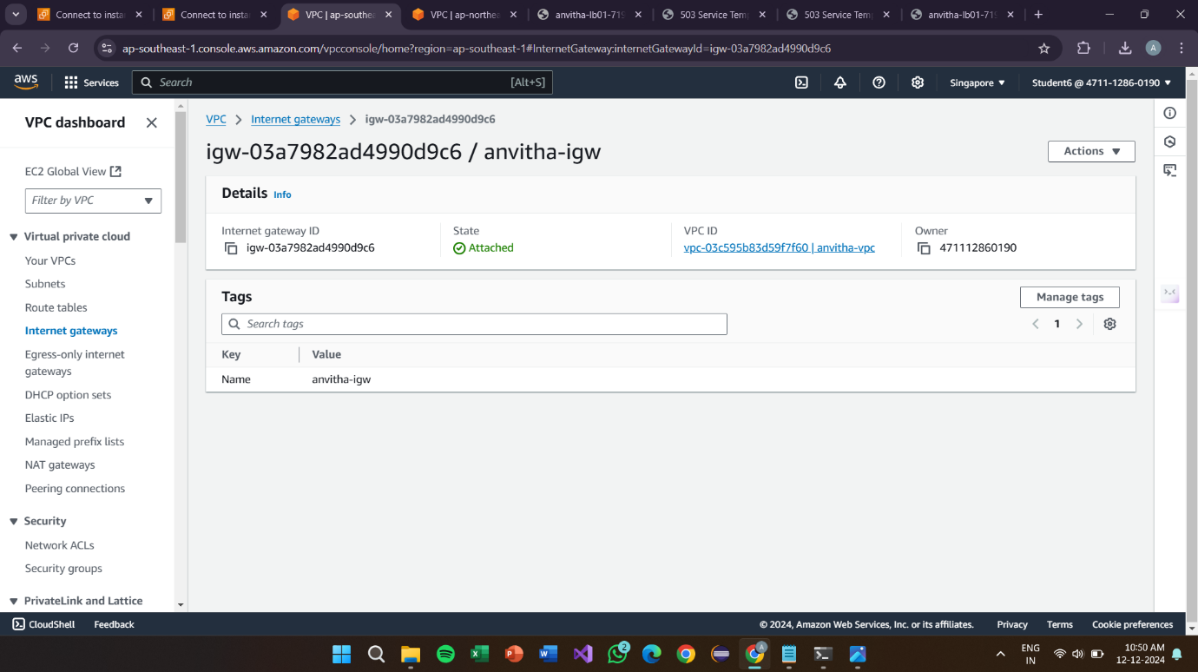

**Create Subnets Steps**

1. In the VPC dashboard, select Subnets.

2. Click the create subnet button to create 2 public and 2 private subnets.

3. Select the VPC created.

4. Provide with the subnet name, availability zone and IPv4 subnet CIDR block for both private and public subnets.

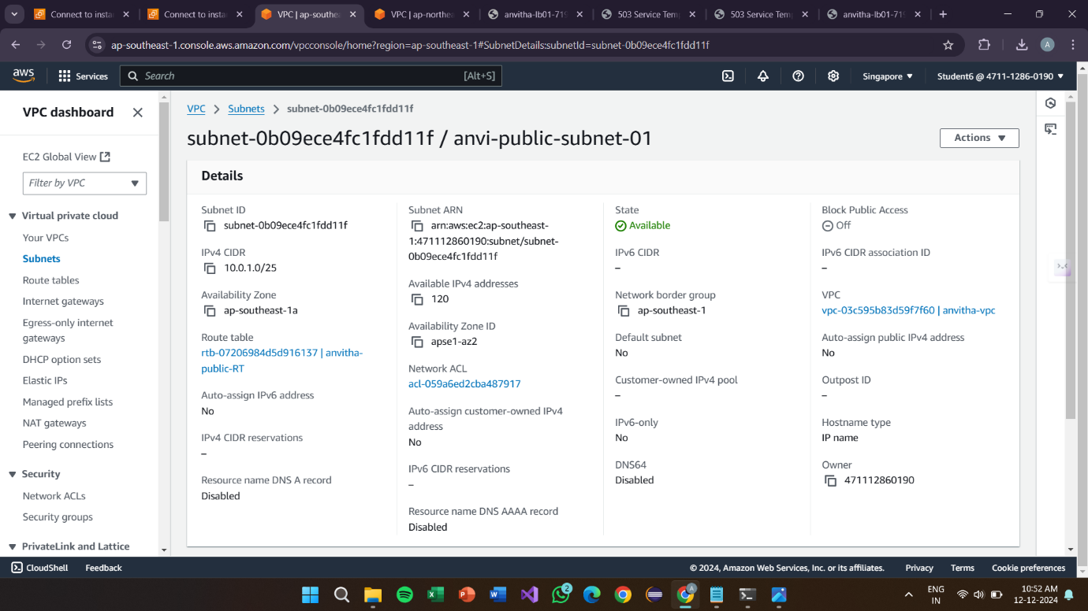

**Public subnet 2**

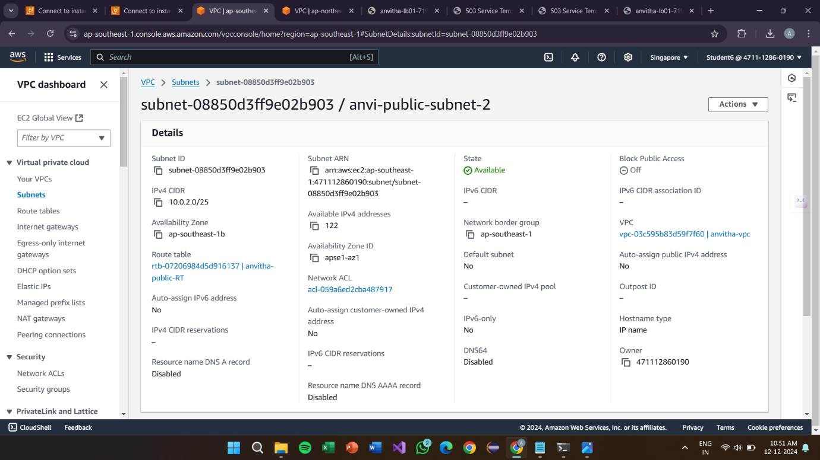

**Private subnet 1**

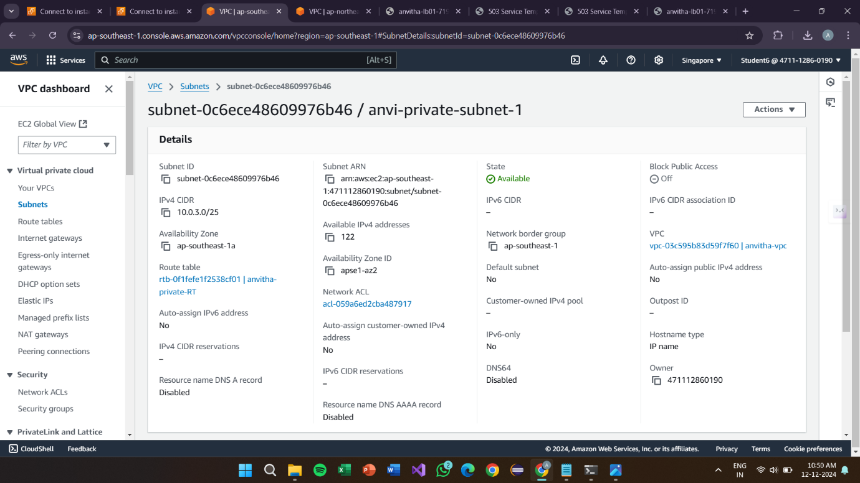

**Private subnet 2**

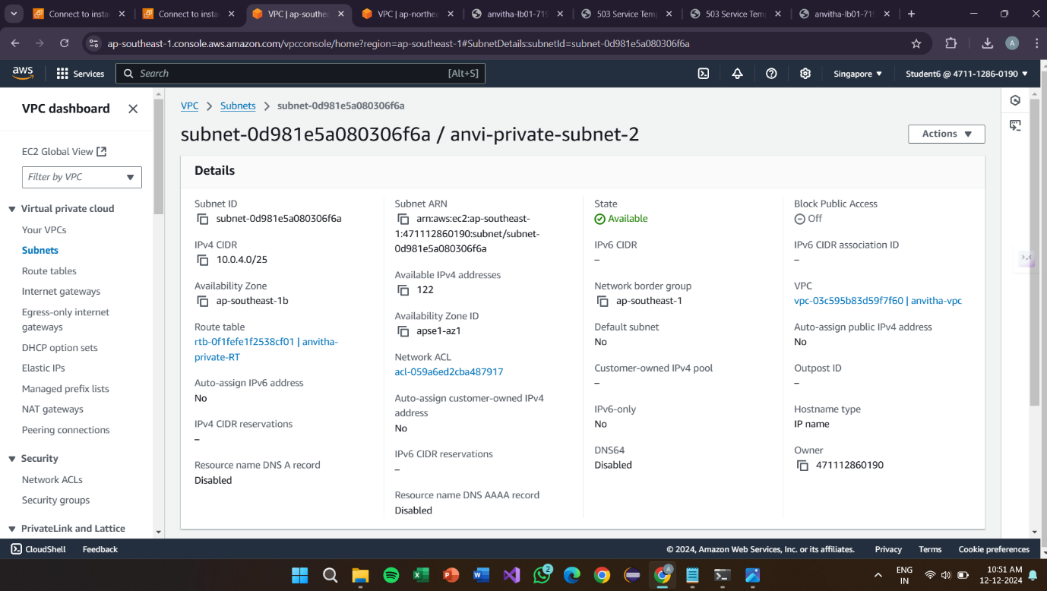

**Create Route Table**

Steps

1. In the VPC dashboard, select Route Table.

2. Click the create route table button.

3. Provide the name as anvitha-private-RT and the created VPC.

4. Under the Subnet Association, click Edit subnet association.

5. Check the private subnets and save association.

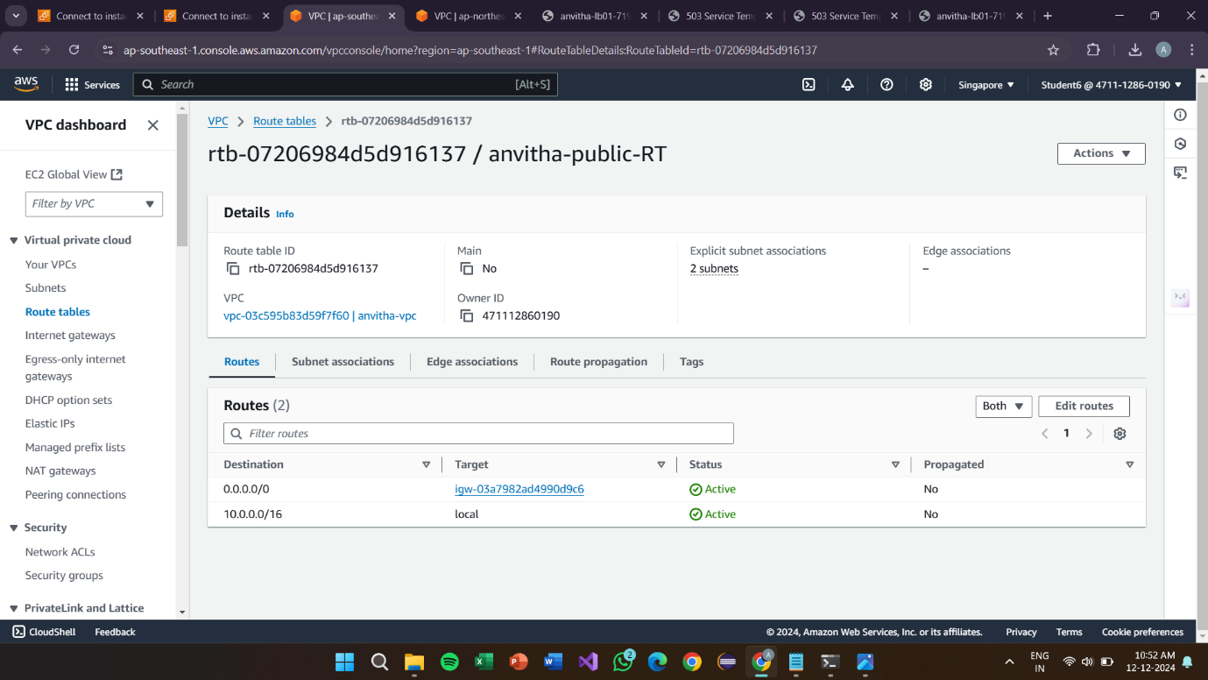

**Private Route Table**

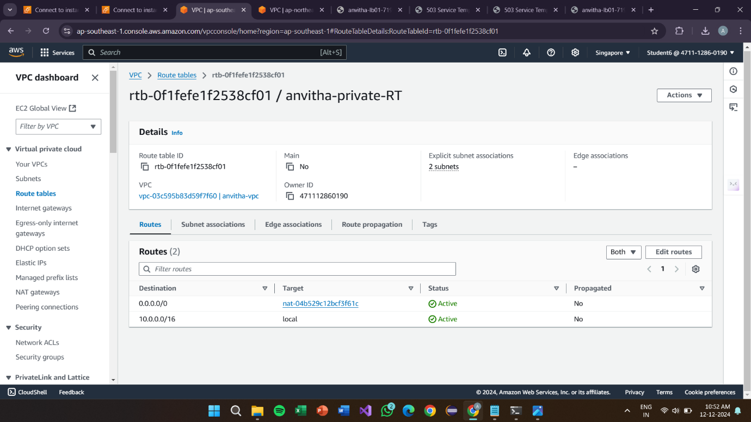

**Create NAT gateway**

Steps

1. In the VPC dashboard, select NAT Gateways.

2. Click the create NAT Gateway.

3. Provide the name as anvitha1-nat and select the created public subnet

and the allocate Elastic IP allocation ID.

4. In the route table check the private-RT and provide the target as NAT

gateway.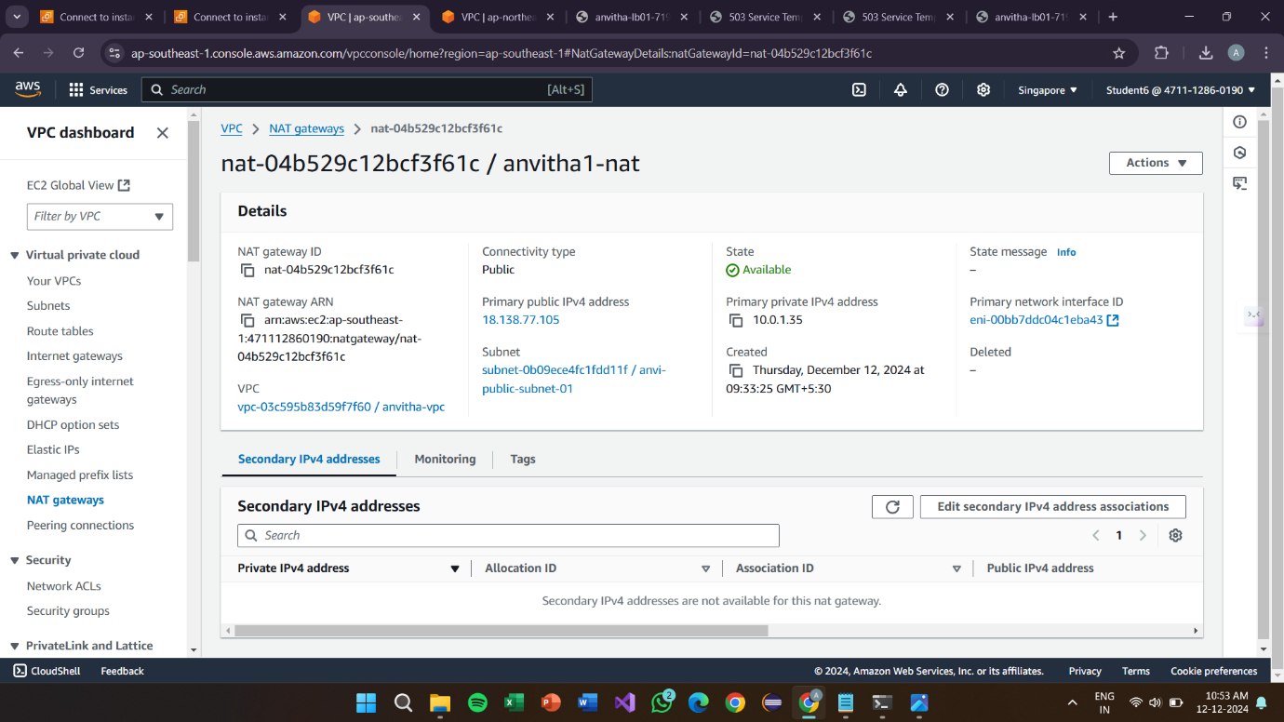

**EC2 Instance**

**Connection**

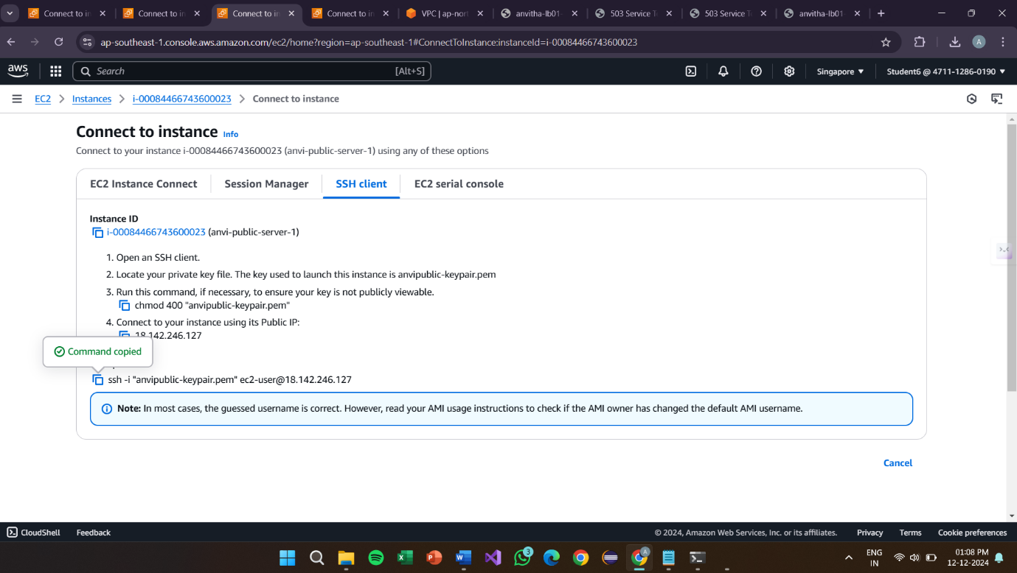

**Connection 2:**

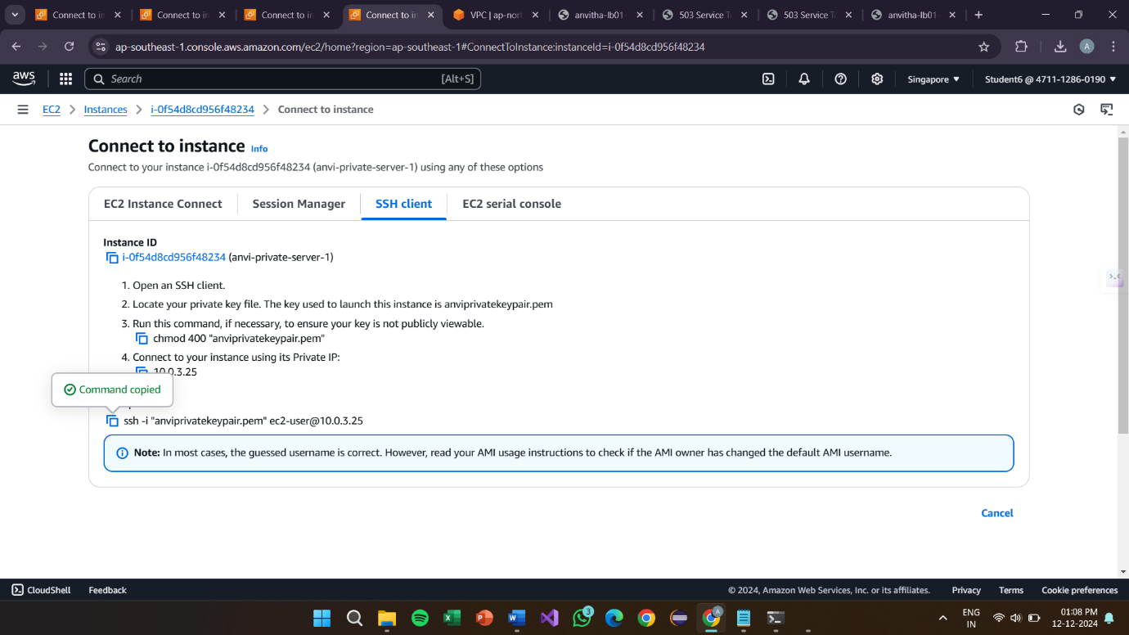

**Final Result in the Command Prompt:**

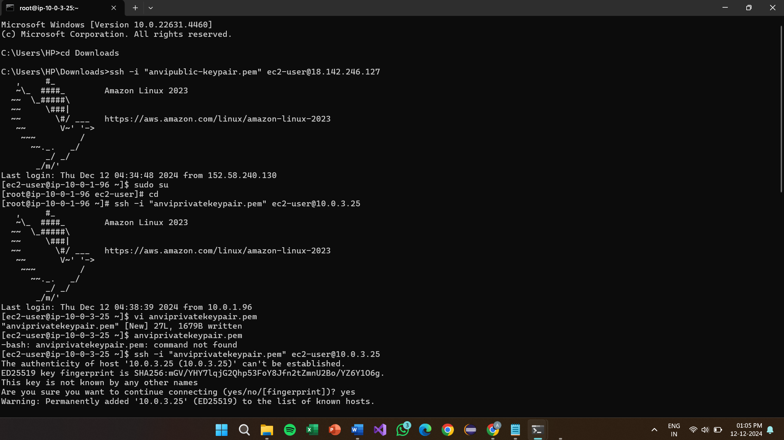

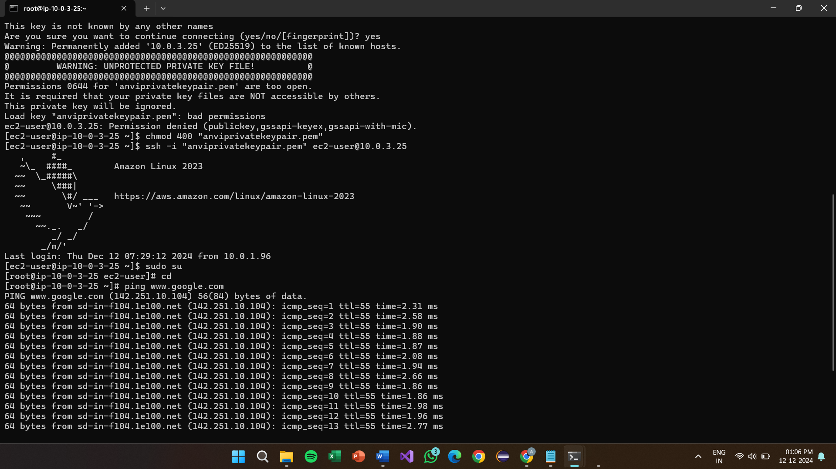

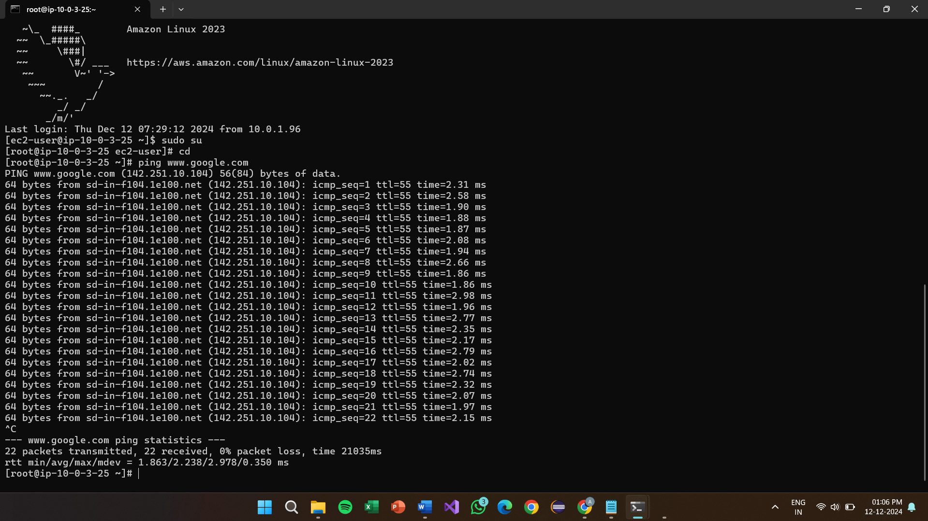

**Project4:**

**Hosting a static website using s3 bucket**

**Create S3 bucket**

Steps

1 .In AWS console, search for S3 bucket.

2. In S3 dashboard, under General purpose buckets click create bucket button.

3. Provide bucket type as General purpose and name as anvitha123. 4. Enable the bucket key.

5.Click the create bucket.

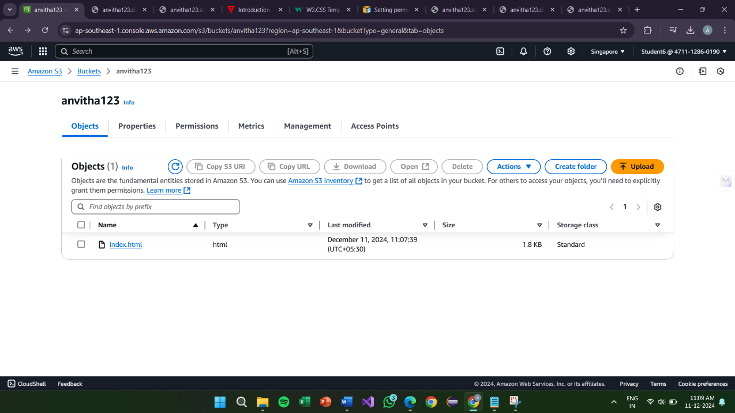

**Upload file**

Steps

1. Click on the bucket that has been create

2. Click on the upload button.

3. Choose the file to upload and click the upload button

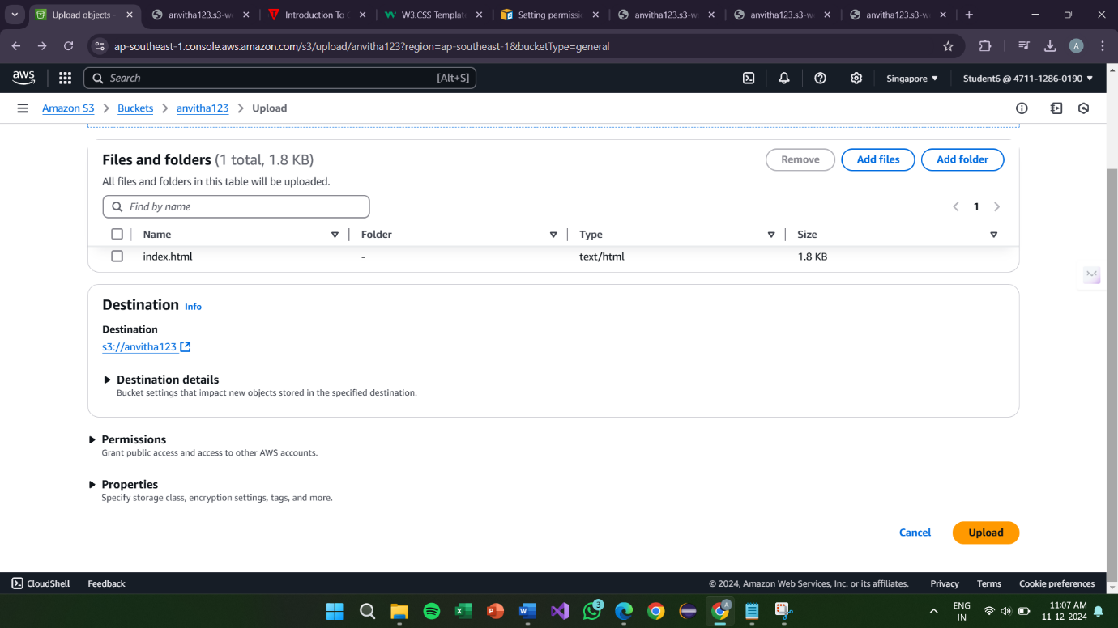

**Static website hosting**

Steps

1. Click on the bucket that has been create.

2. Under the properties,click edit static webste hosting.

3. Provide the index document as index.html

4. Click the save changes.

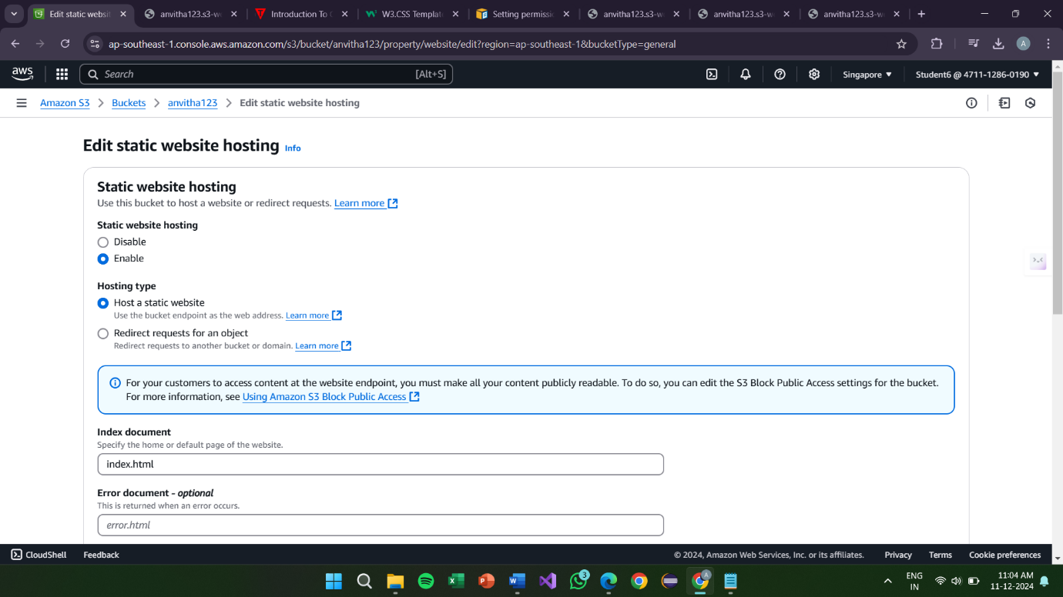

**Edit block public access(bucket settings)**

Steps

1. Under permission, click Edit Block public access.

2. Uncheck Block of public access and confirm

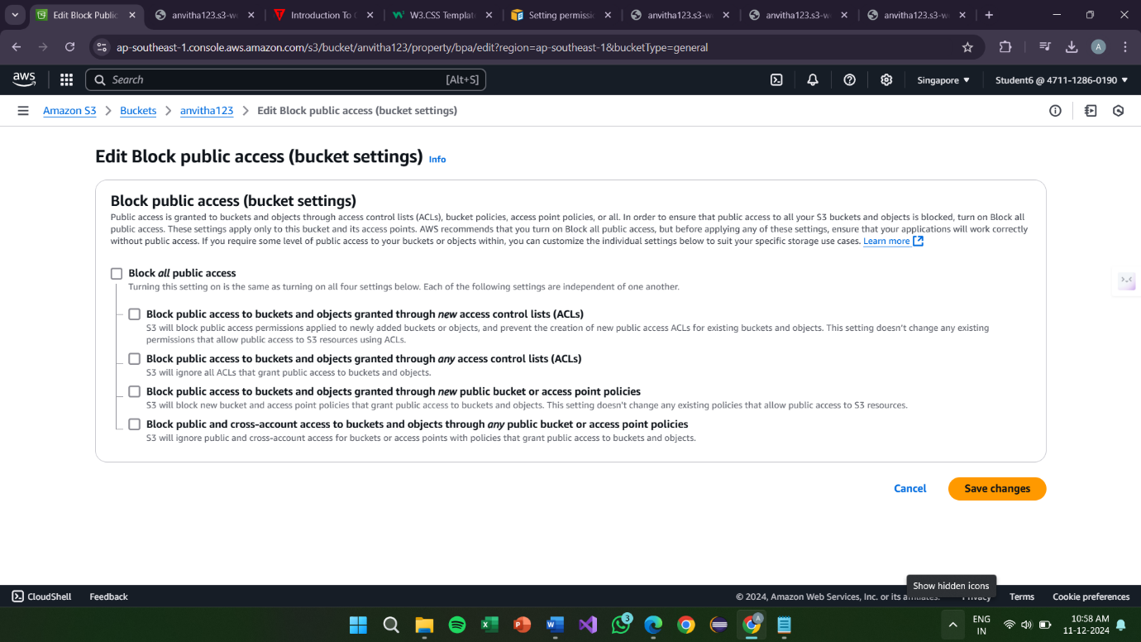

**Edit block policy**

Steps

1. Under permission, click Edit Bucket policy.

2. In chrome, search Bucket policy for static website and copy the code of step 2.

3. Paste in bucket policy and provide the bucket name as anvitha123

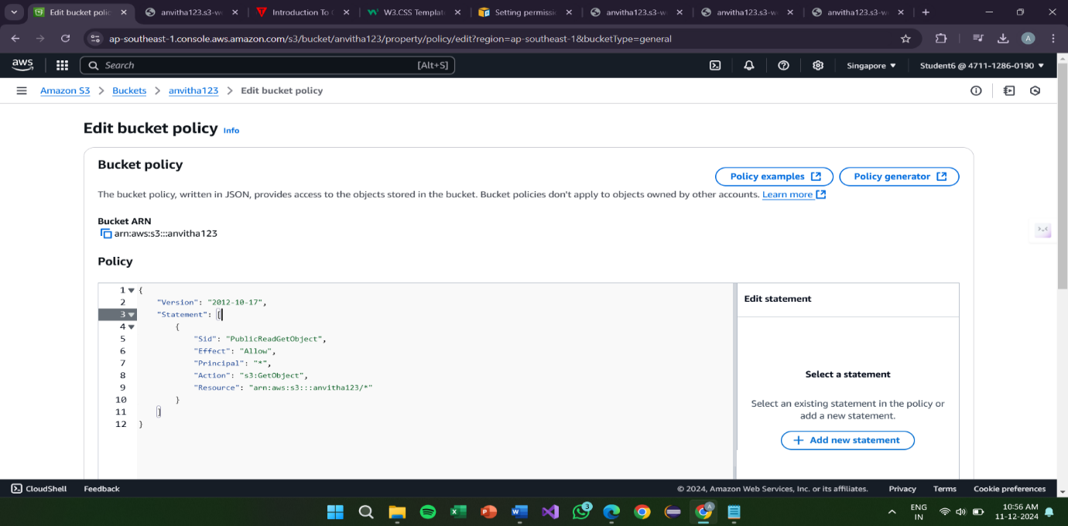

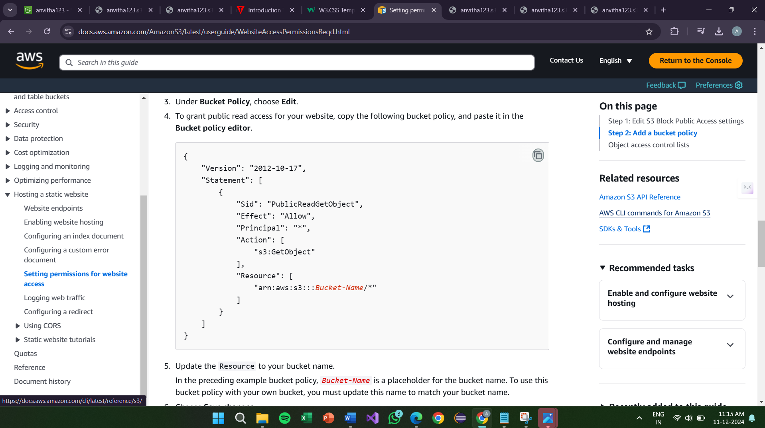

**Final Result:**

Under properties copy the url of static website hosting

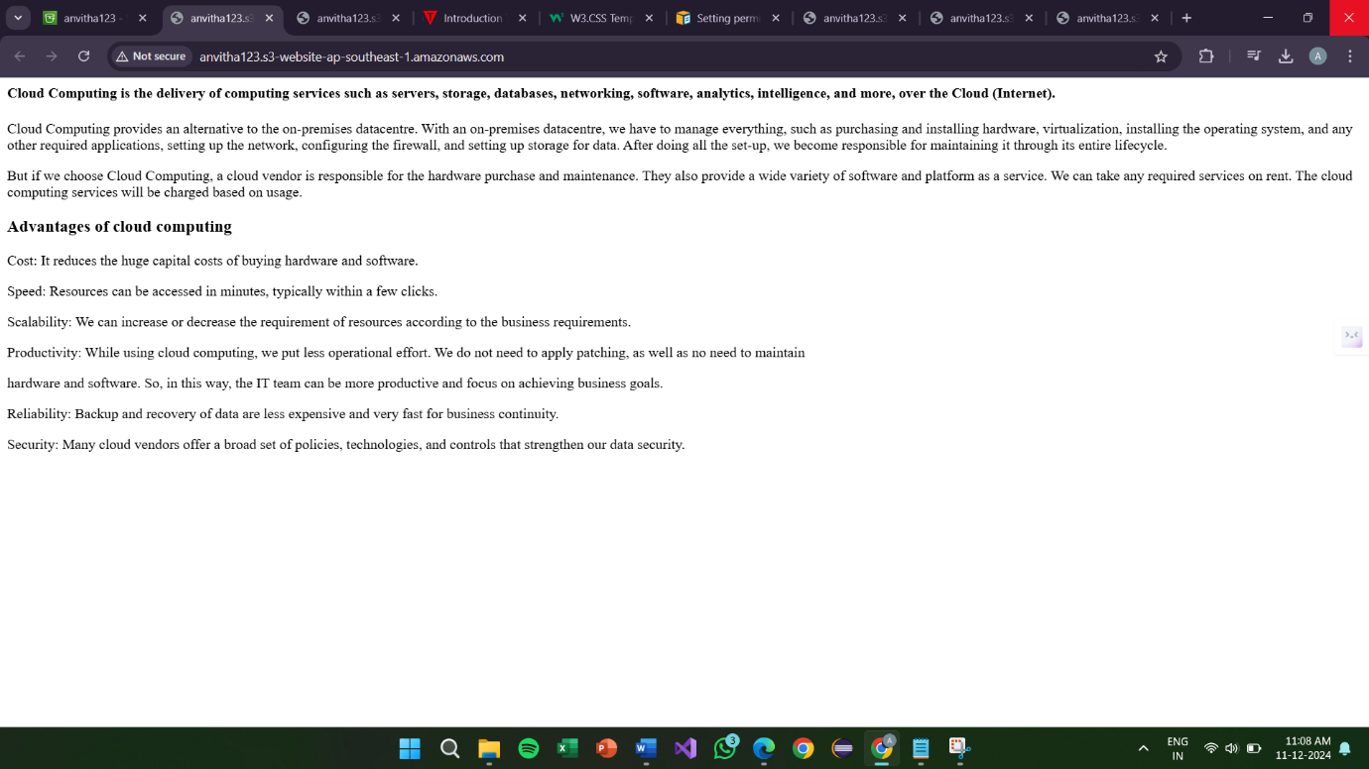

**Project 5:**

**Lauching the website using using Load balancer DNS Name**

**Creating VPC:**



**Internet Gateway**



**Private subnet-1**



**Private subnet-2**



**Public subnet-2**



**Public subnet-1**



**Private Route Table**



**Public Route Table**



**Nat gateway**



**Load Balancer**

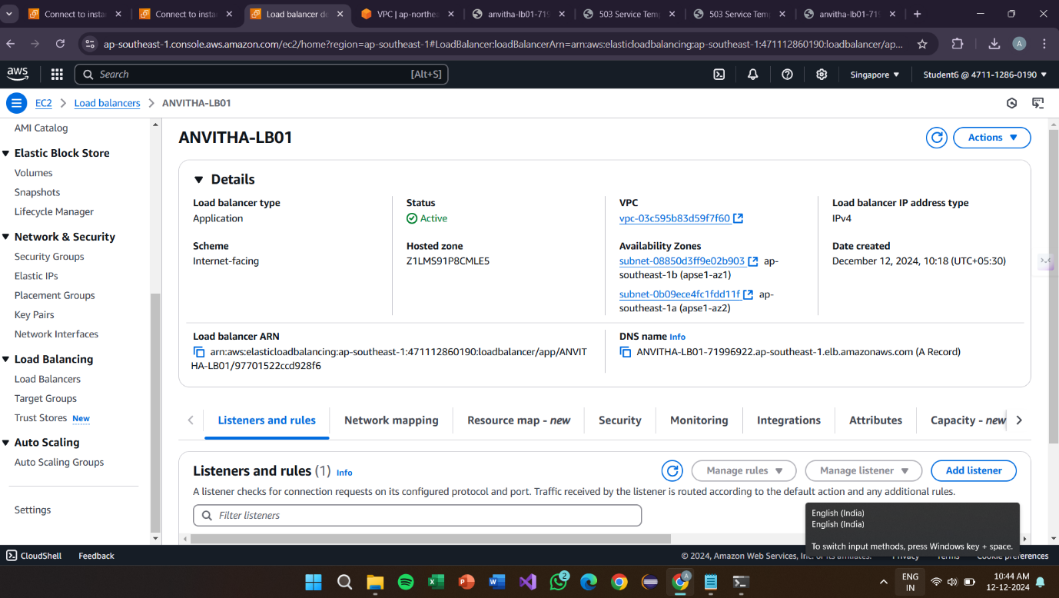

**Registered Targets**

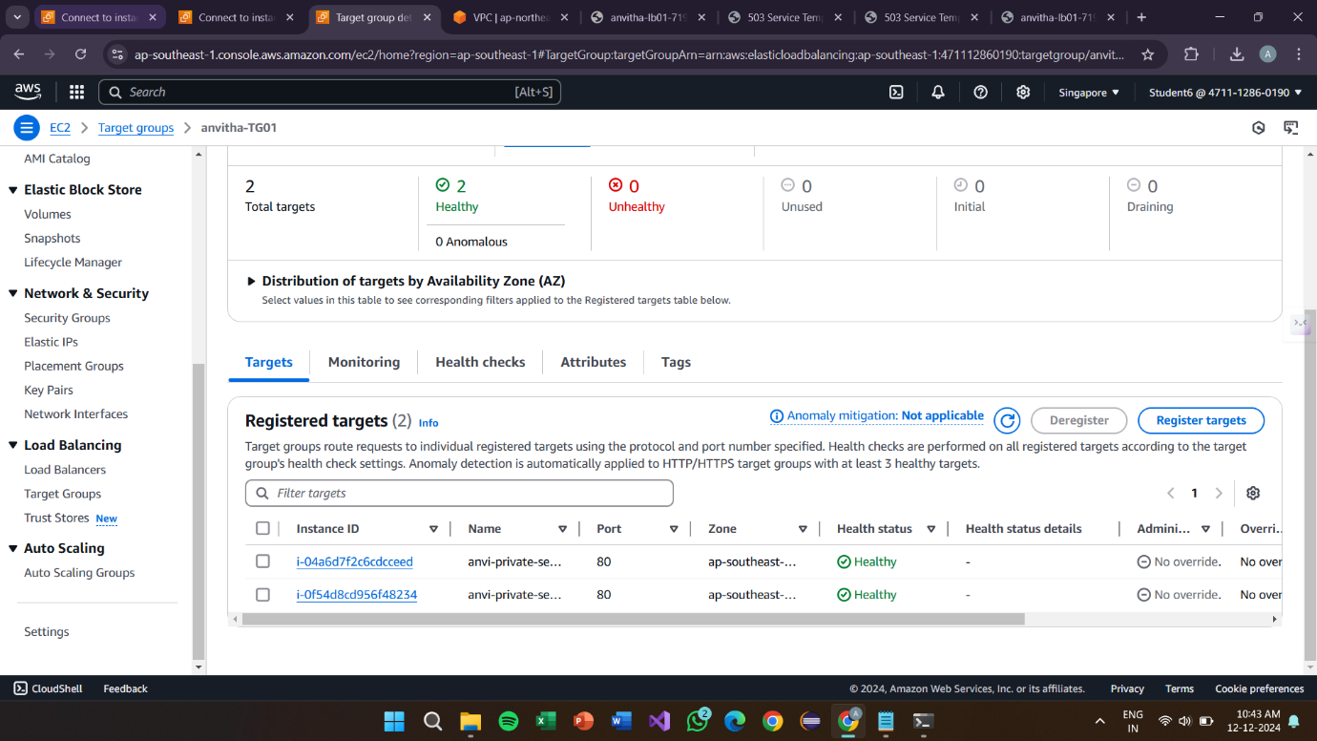

**Target Groups**

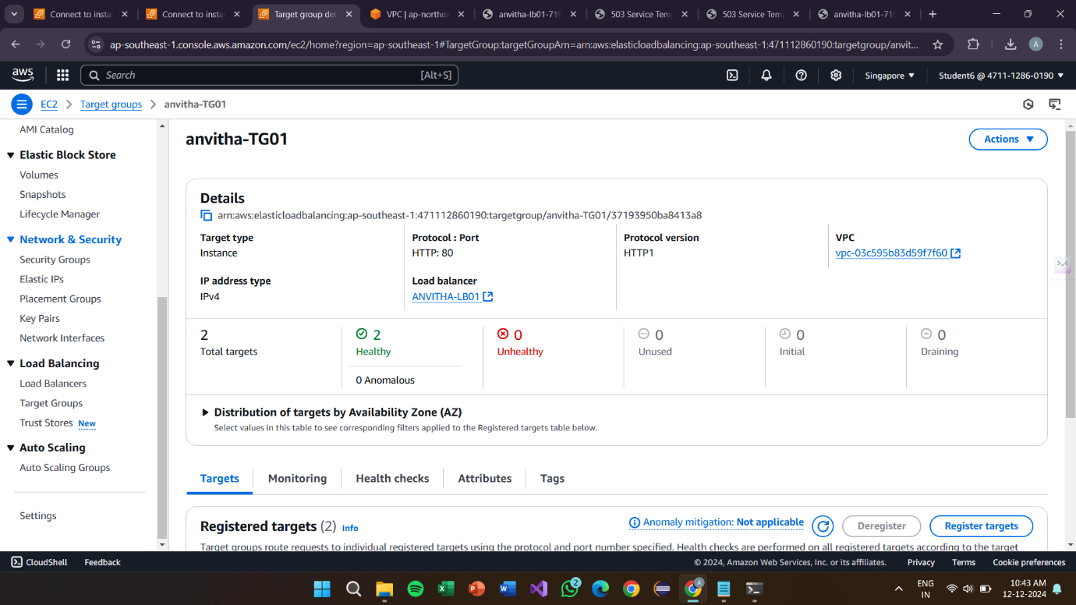

**EC2 Instance**

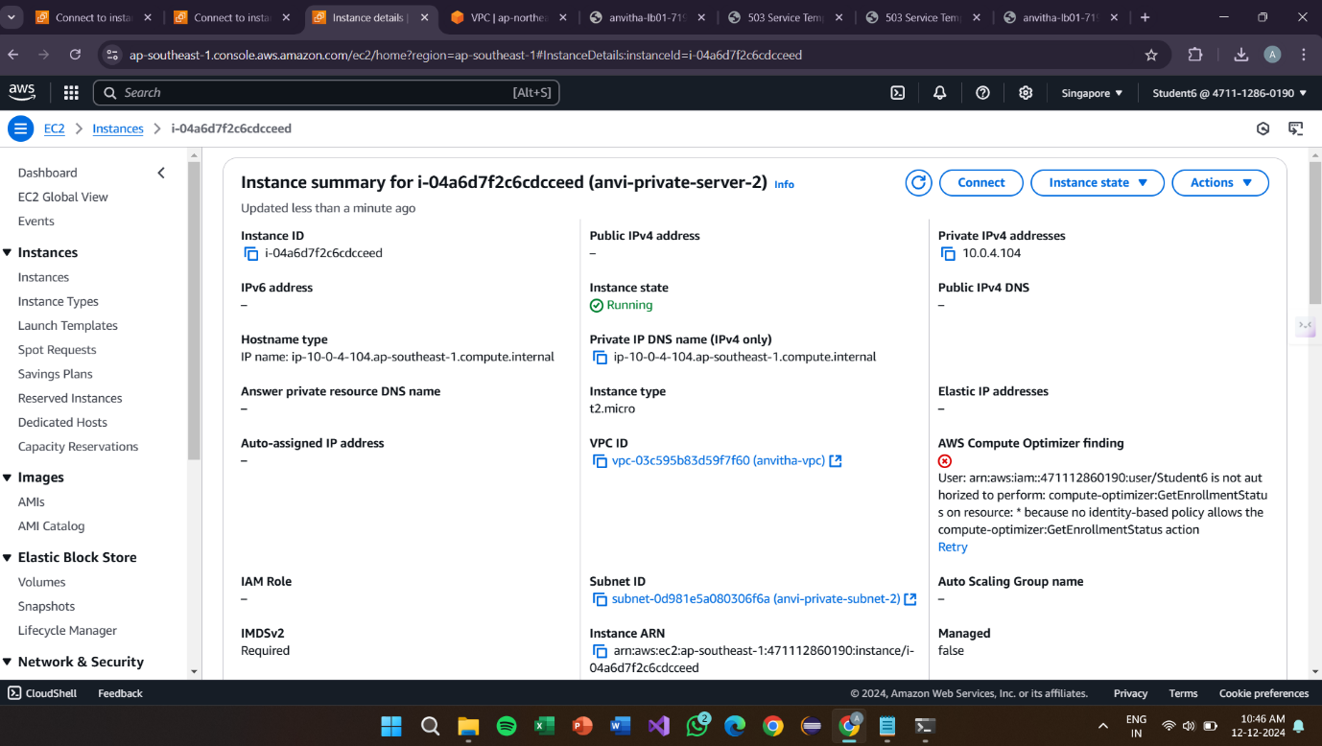

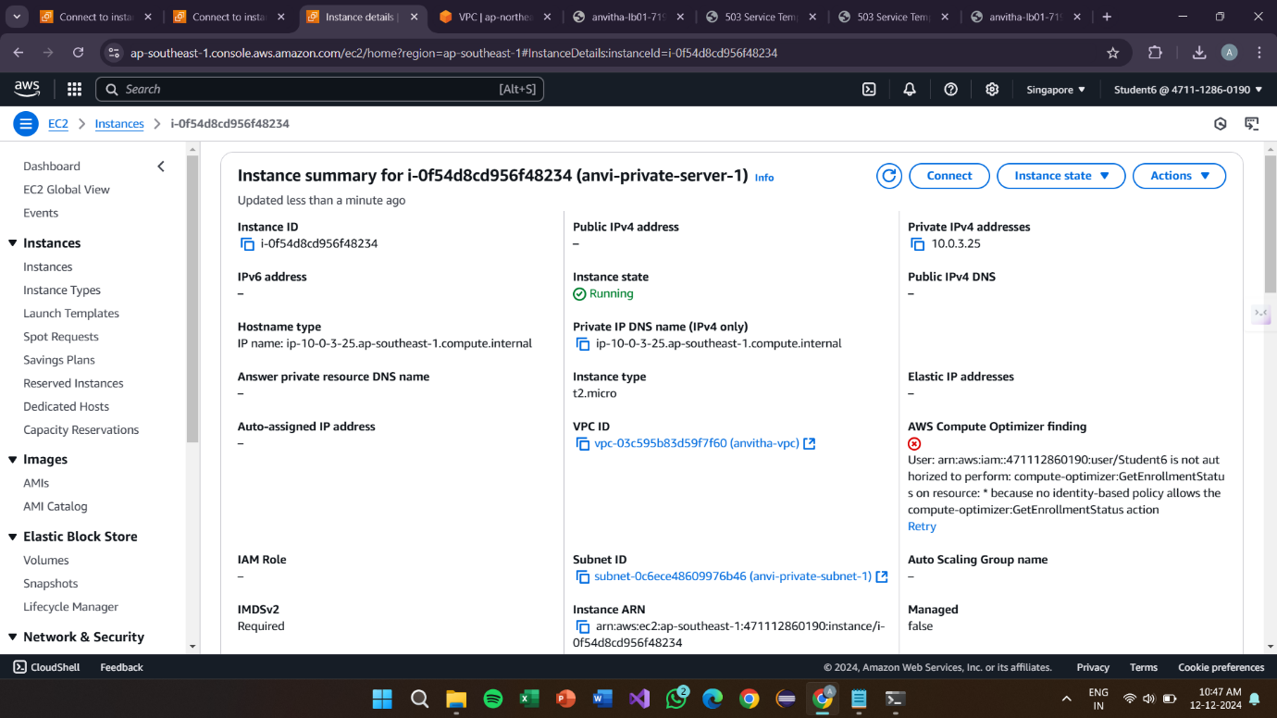

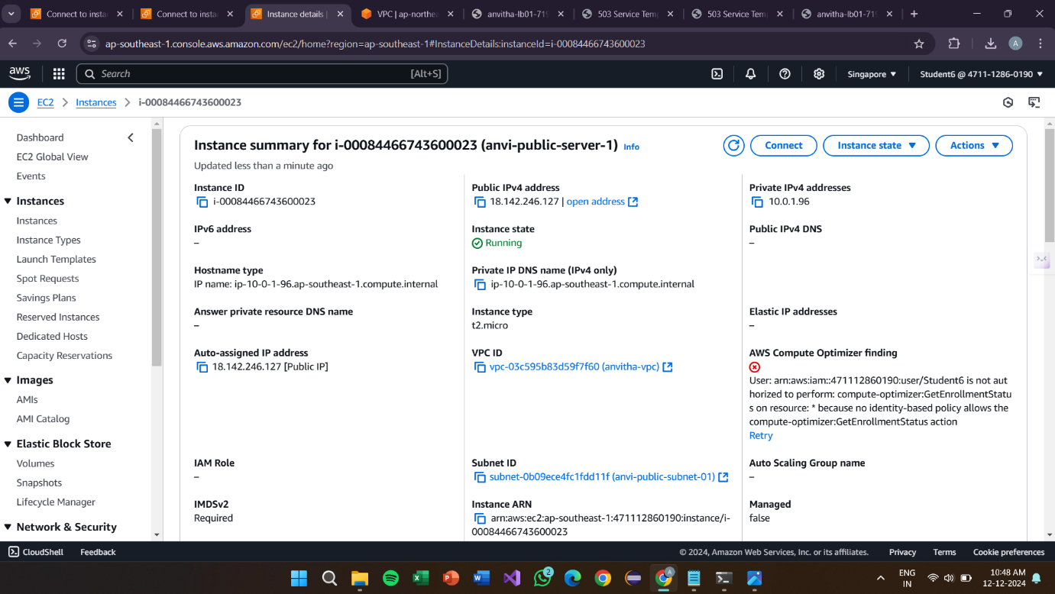

**Connection:**

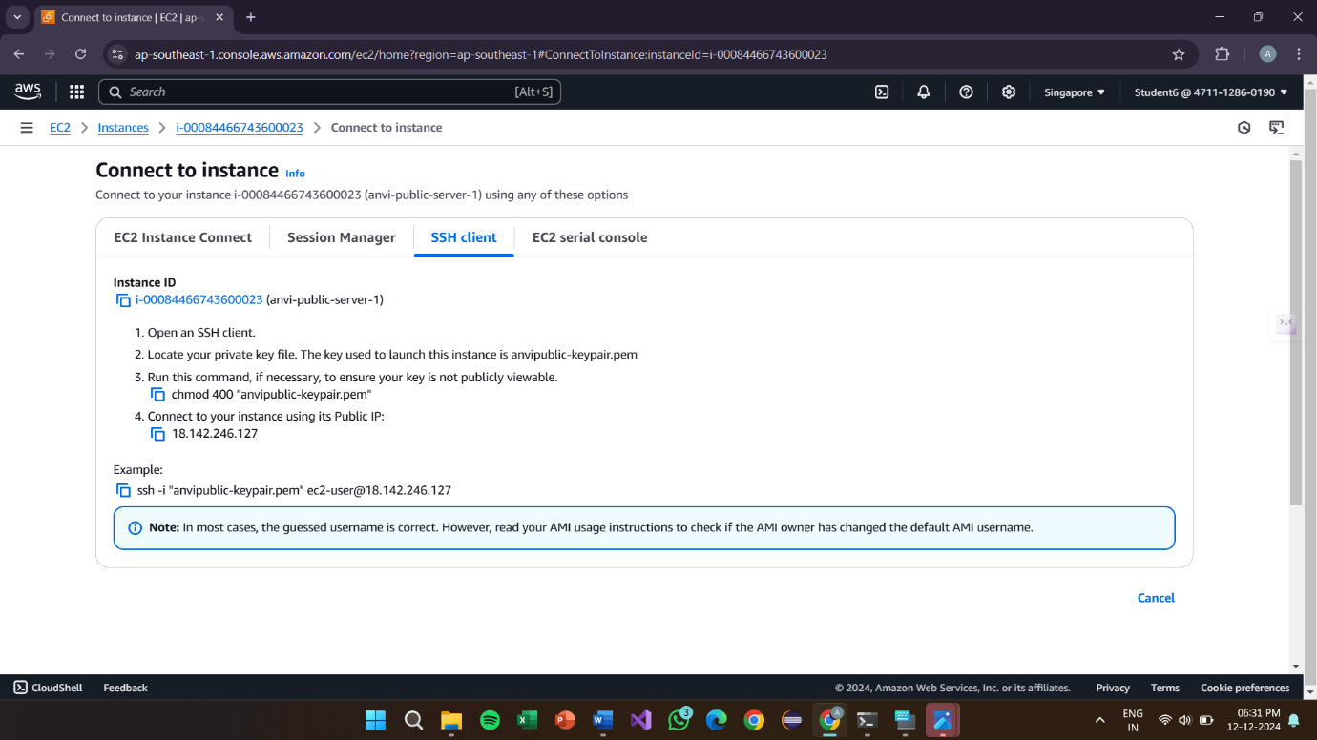

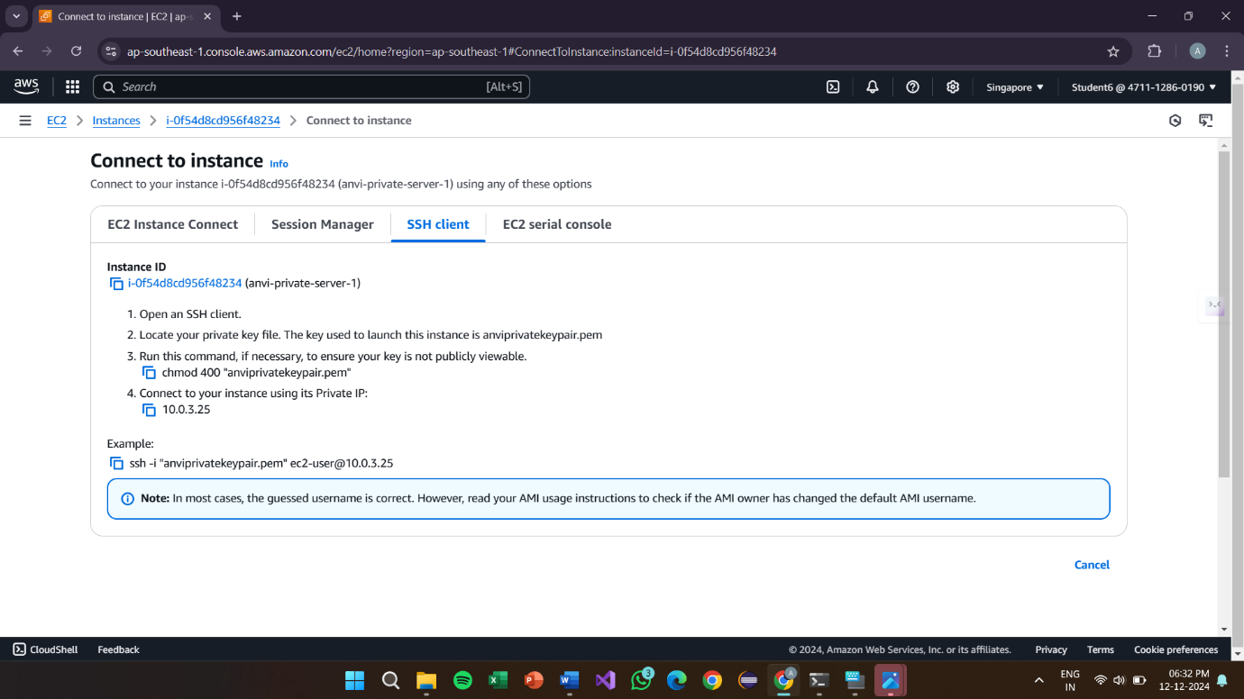

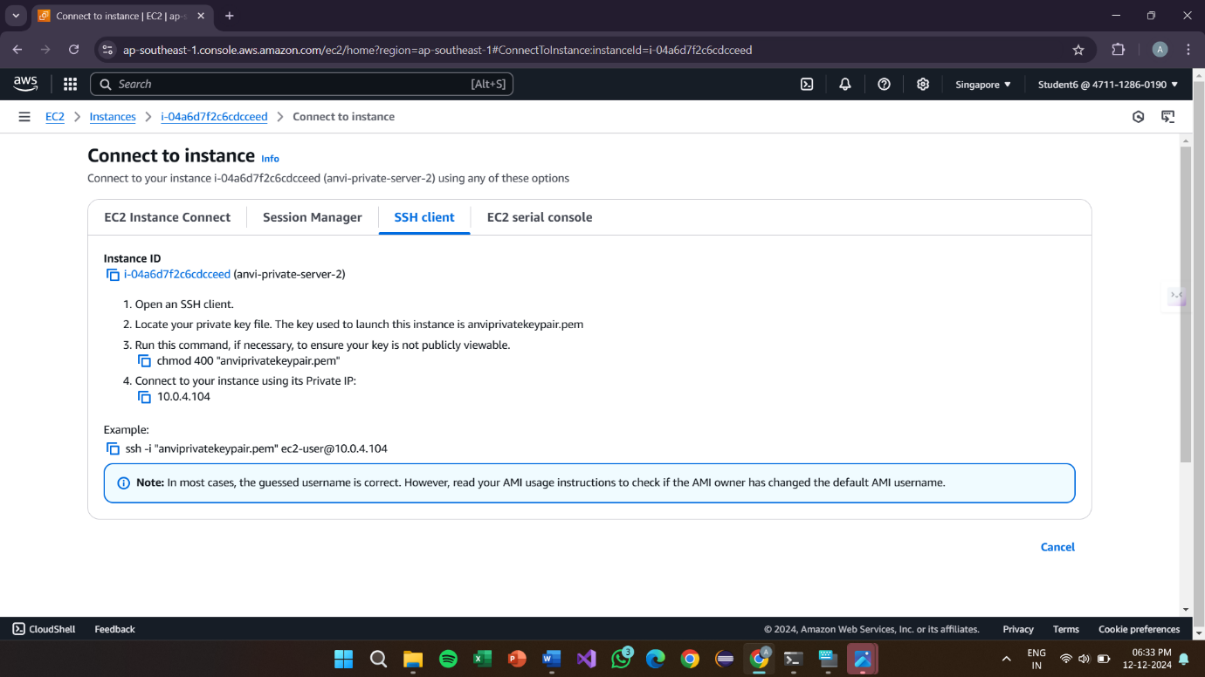

**Command Prompt:**

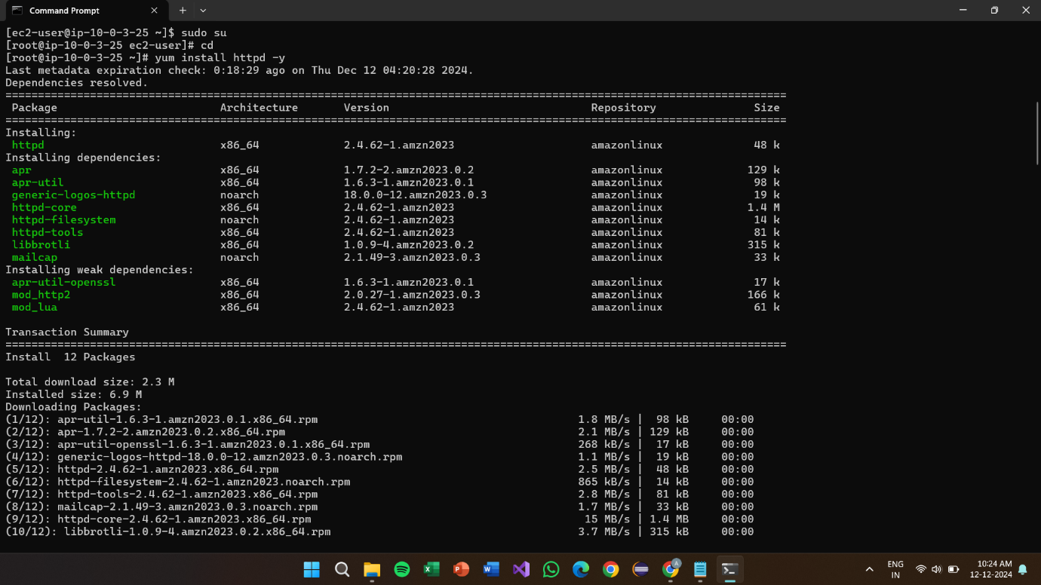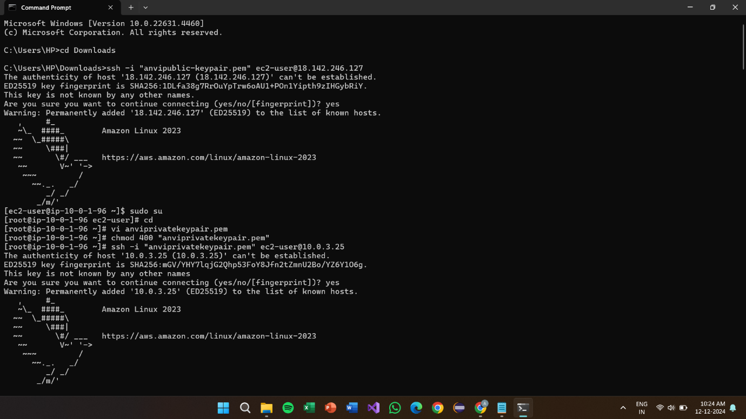

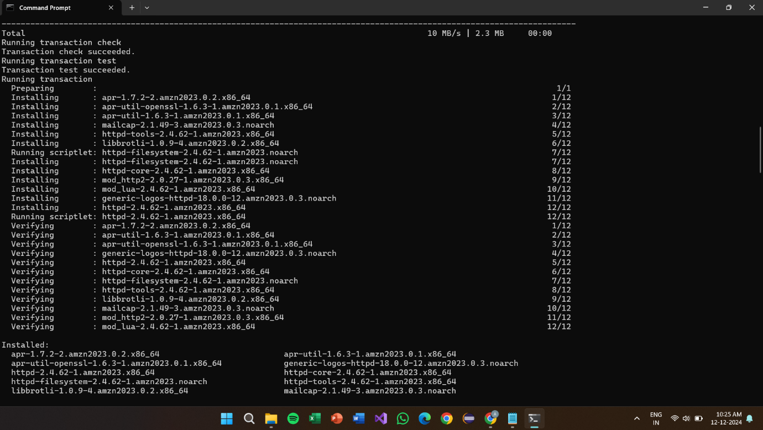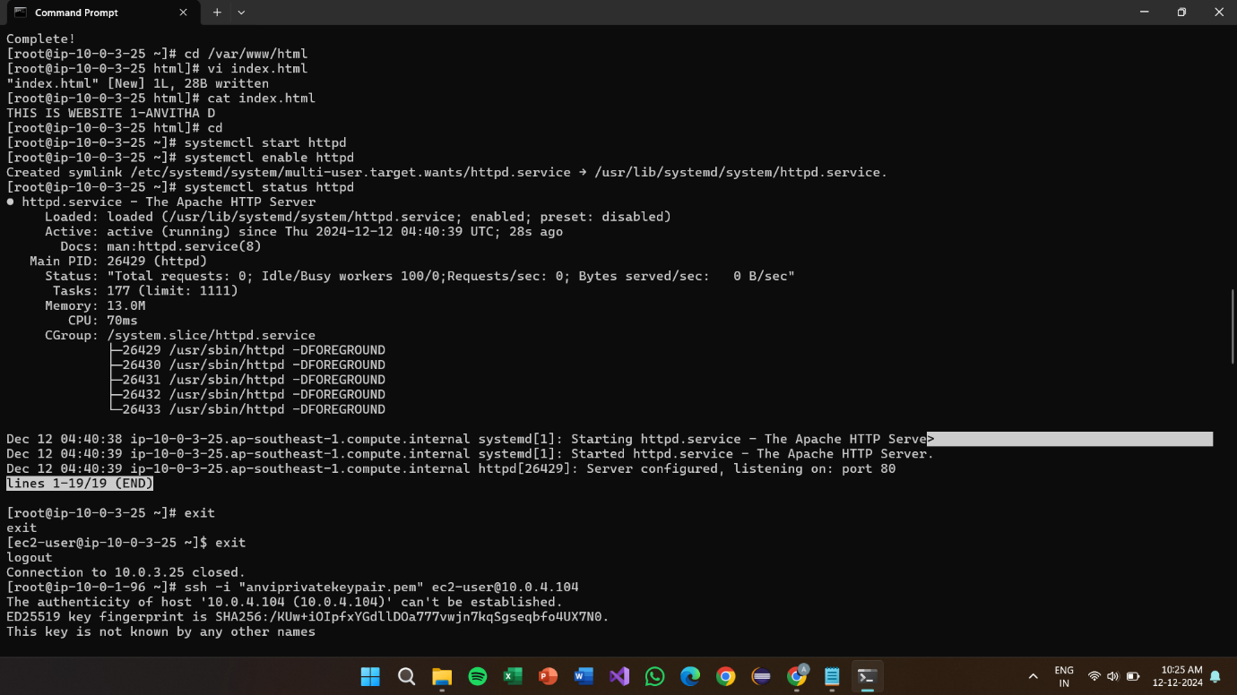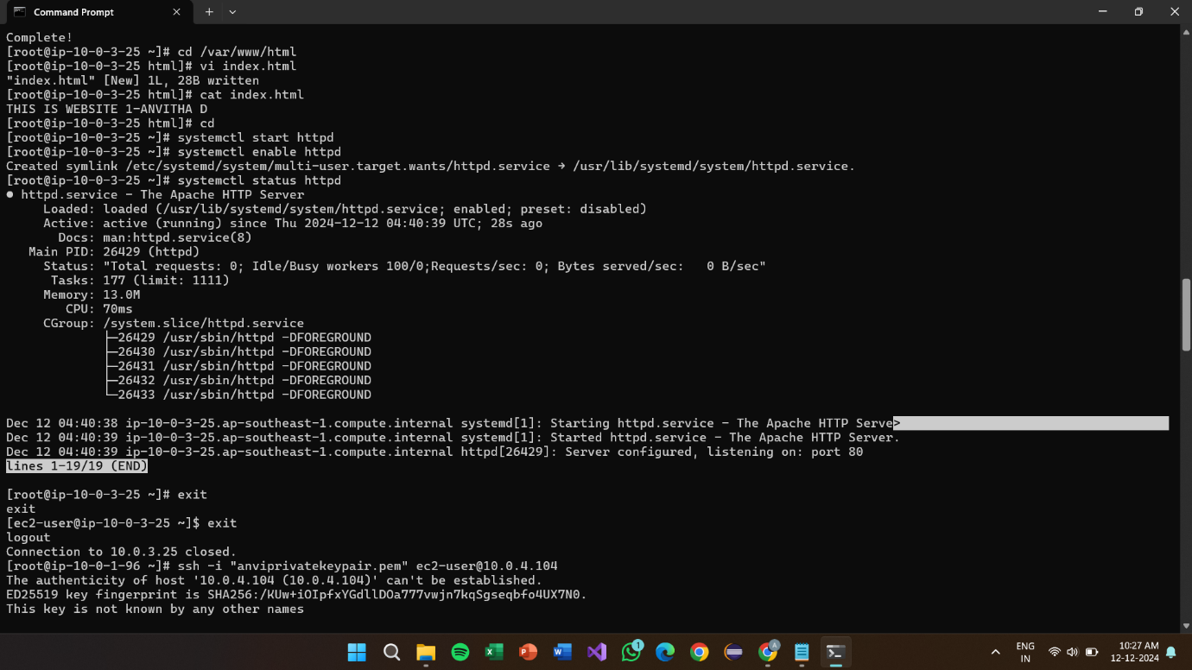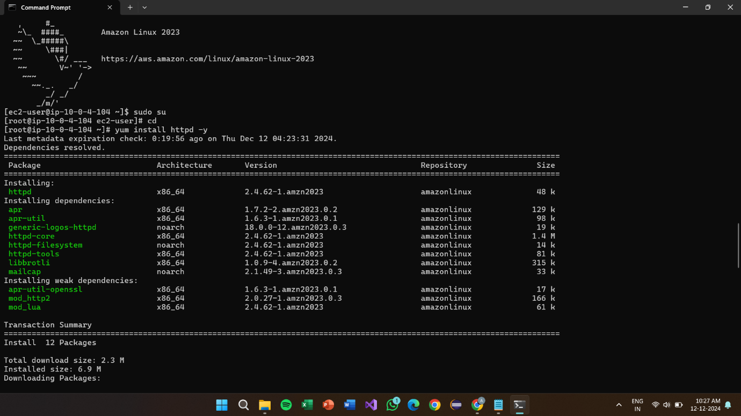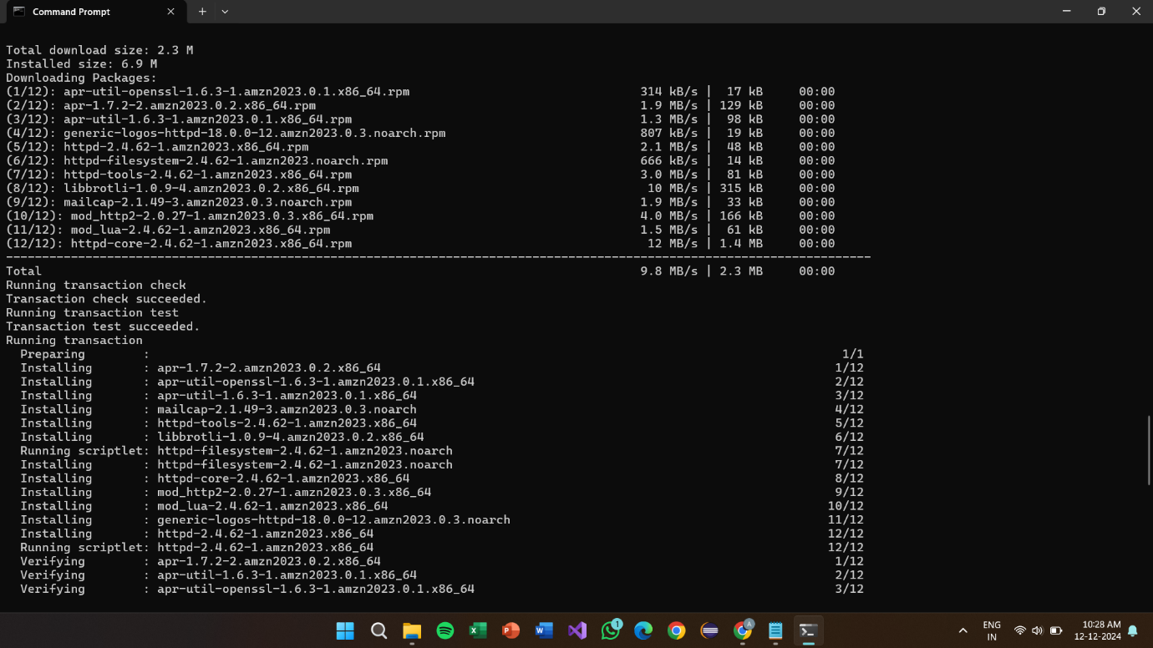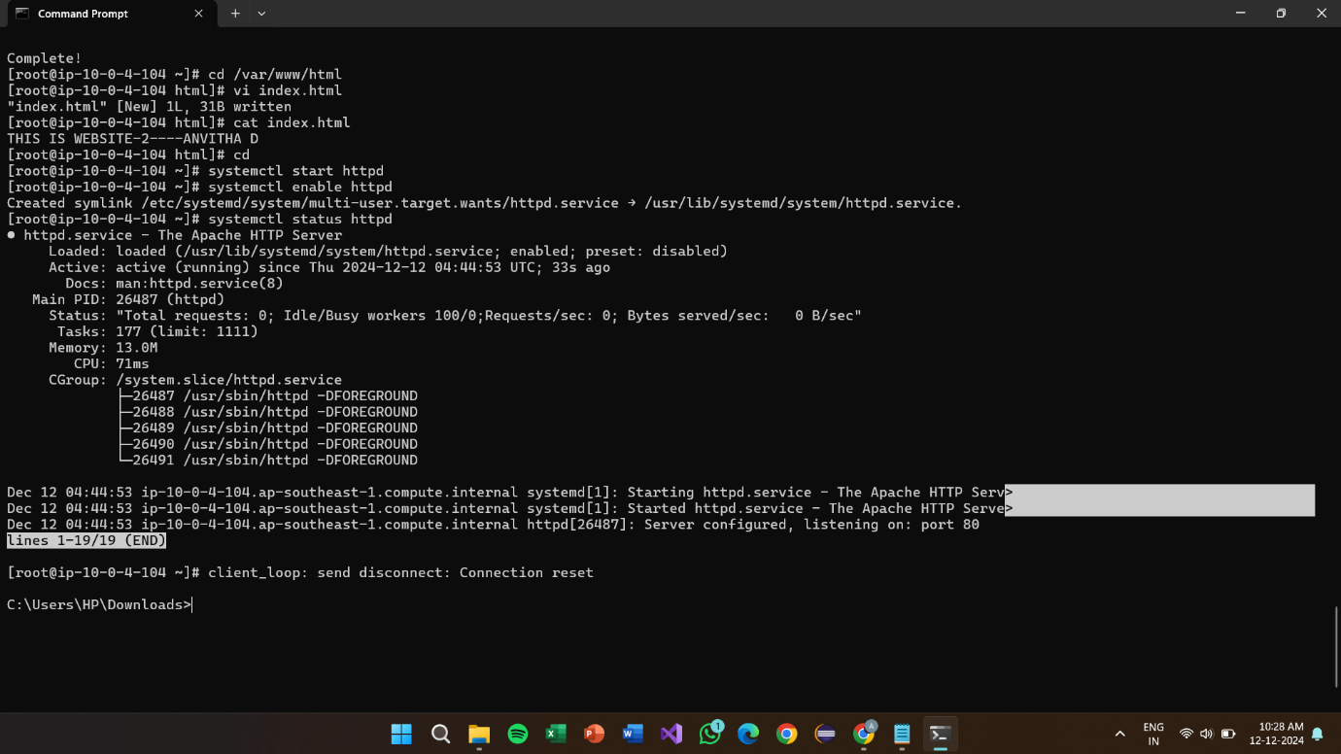

**Result:**

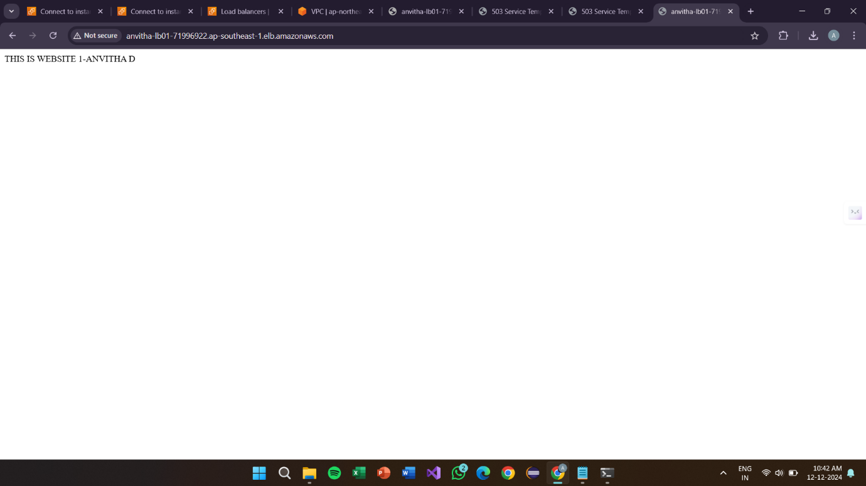

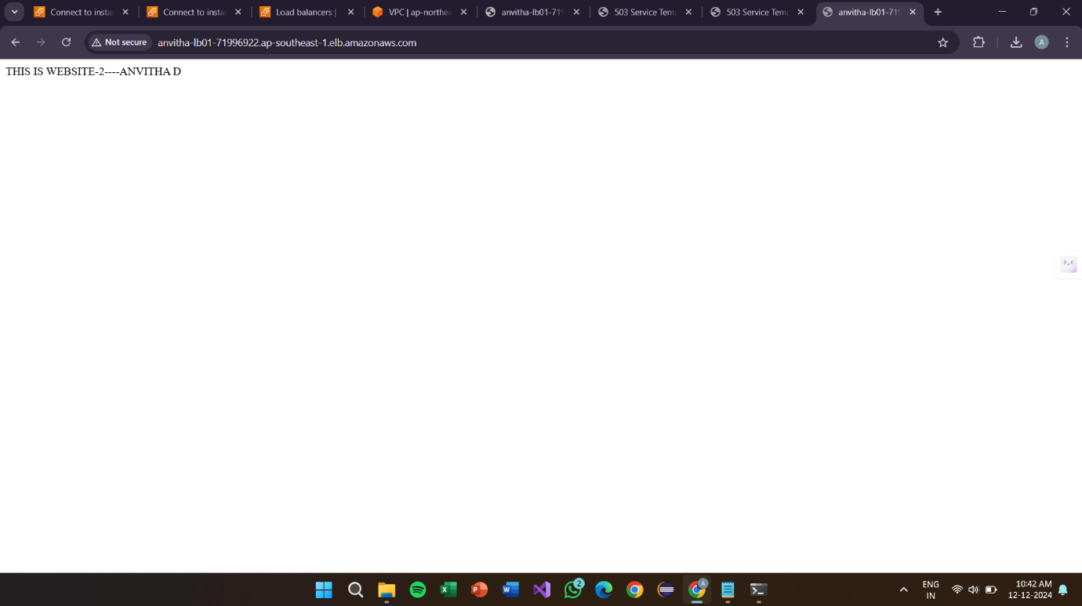

**Project-6:**

**How to create the repository of branch name and how to pull that in the local repository in the githubs**

**VPC:**



**Internet Gate way:**

**Subnets**



**Route Table: **

**GIT-Server**

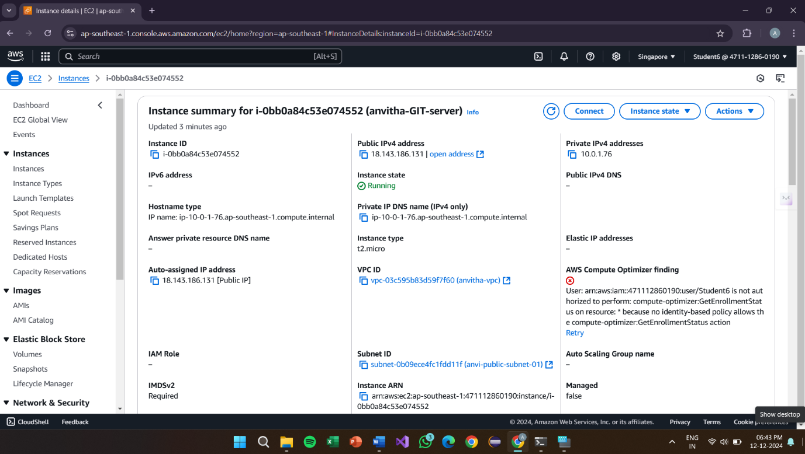

**Security Group**

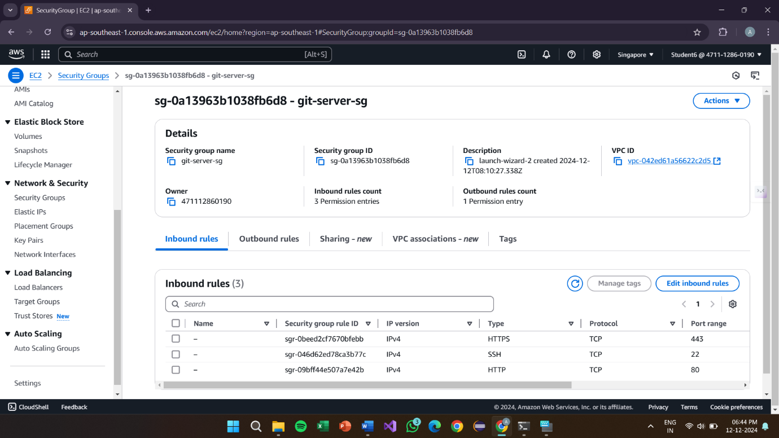

**Connection:**

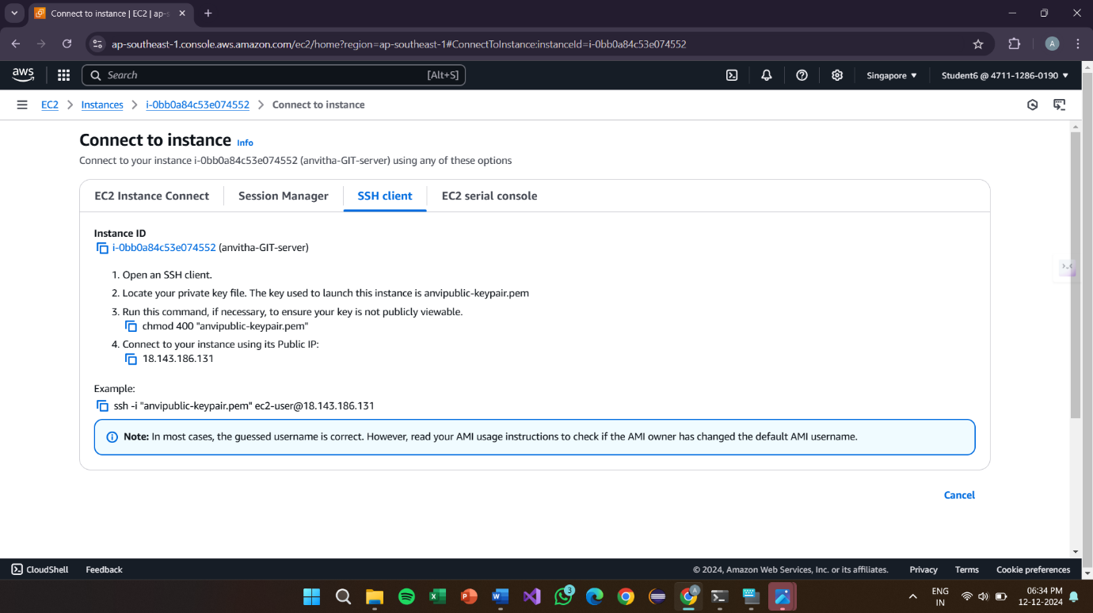

**Create Git**

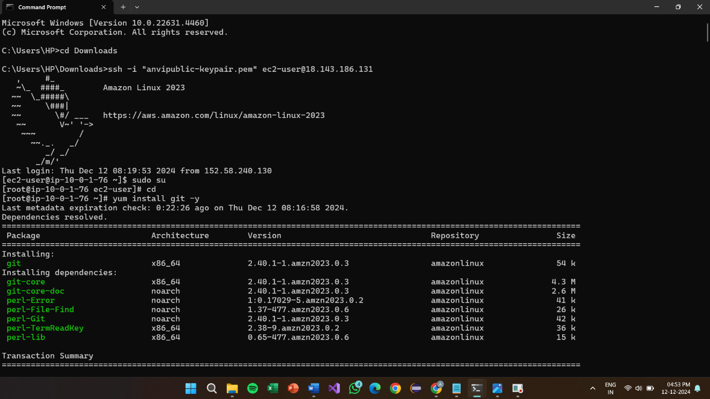

s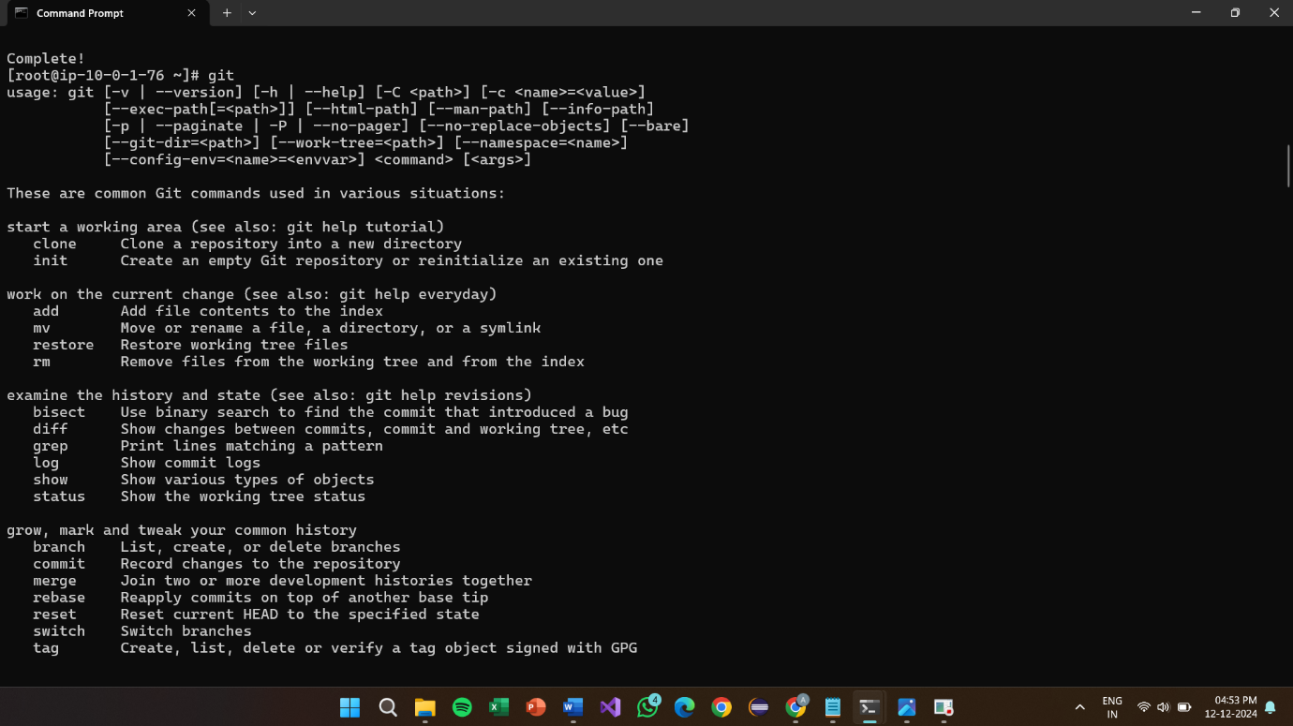 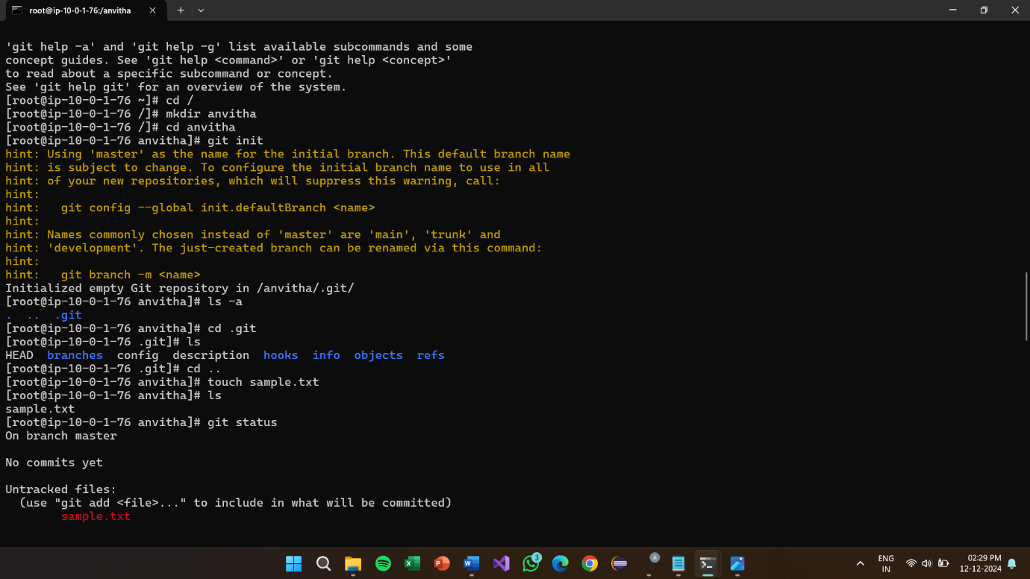

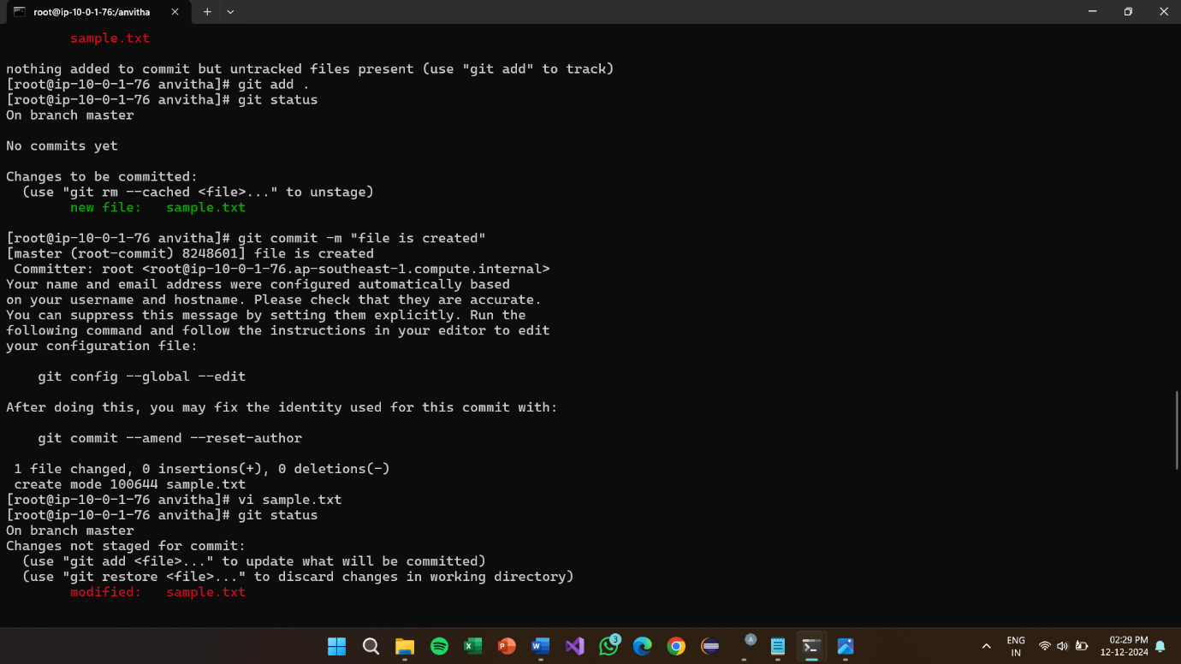

**GIT CLONE**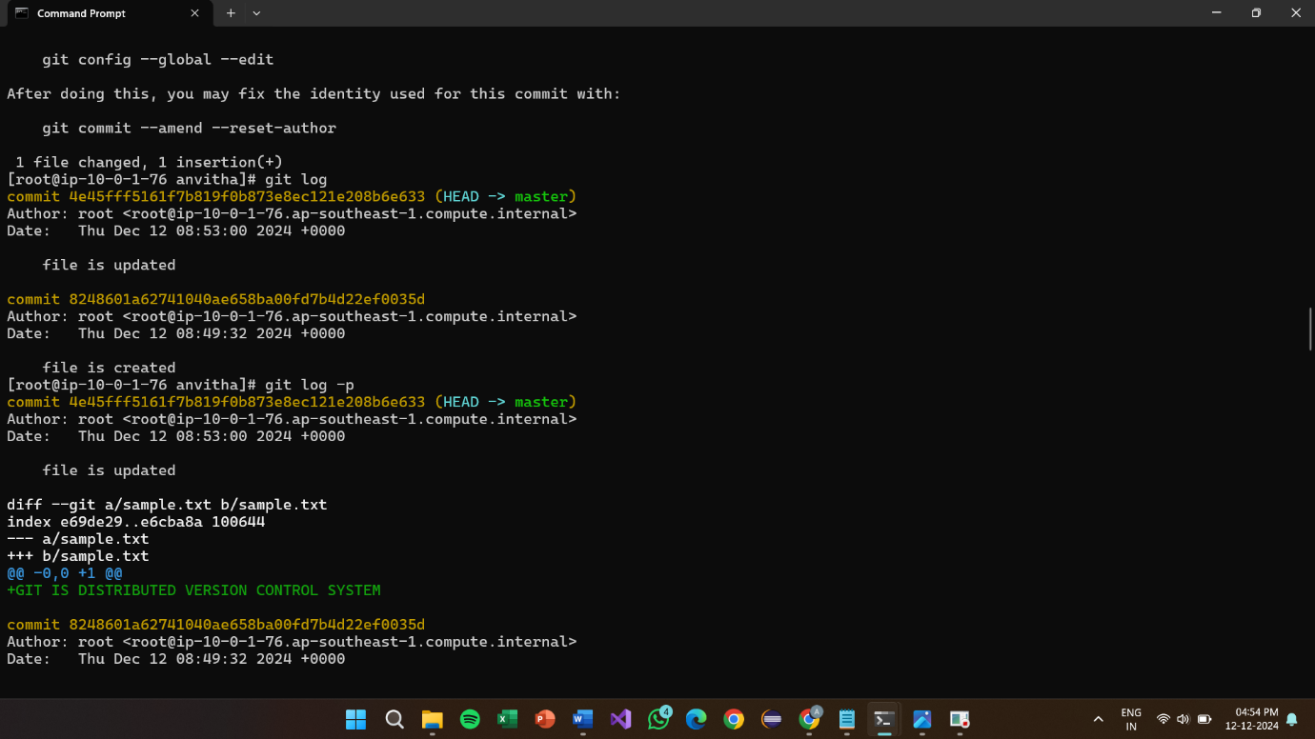

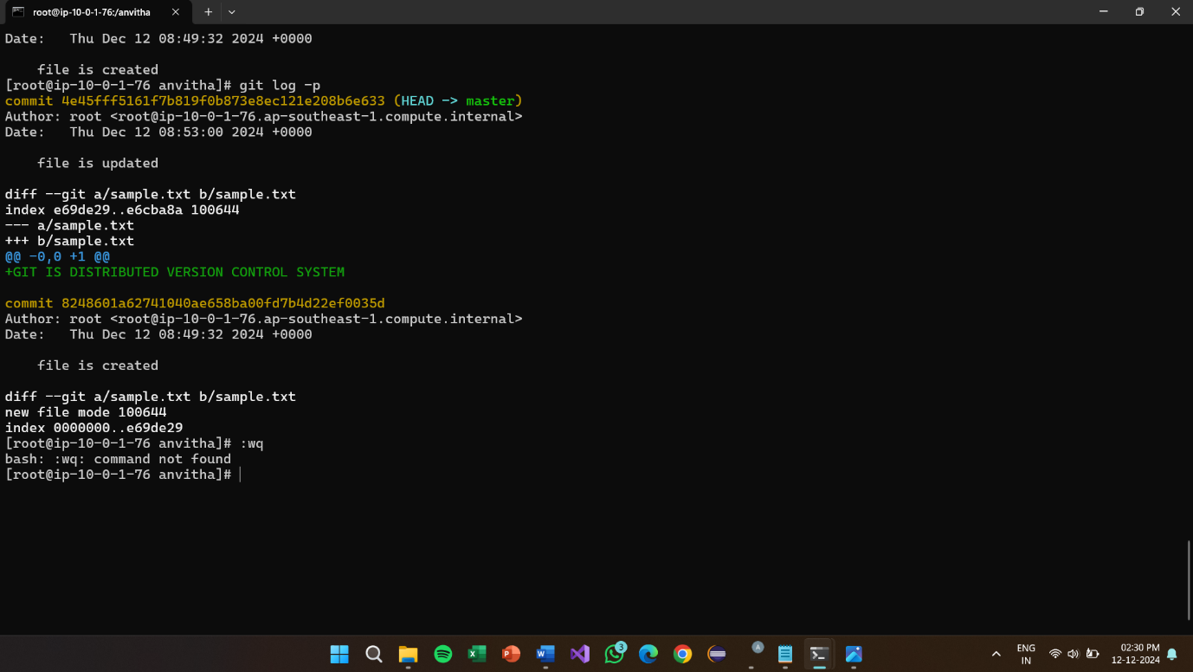

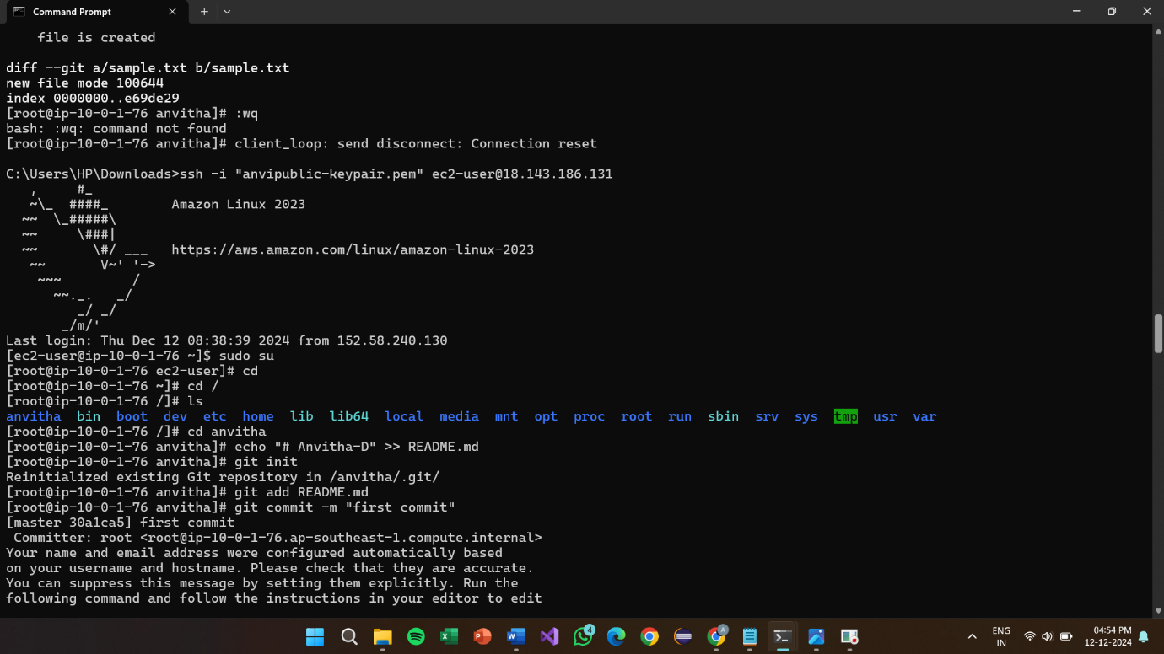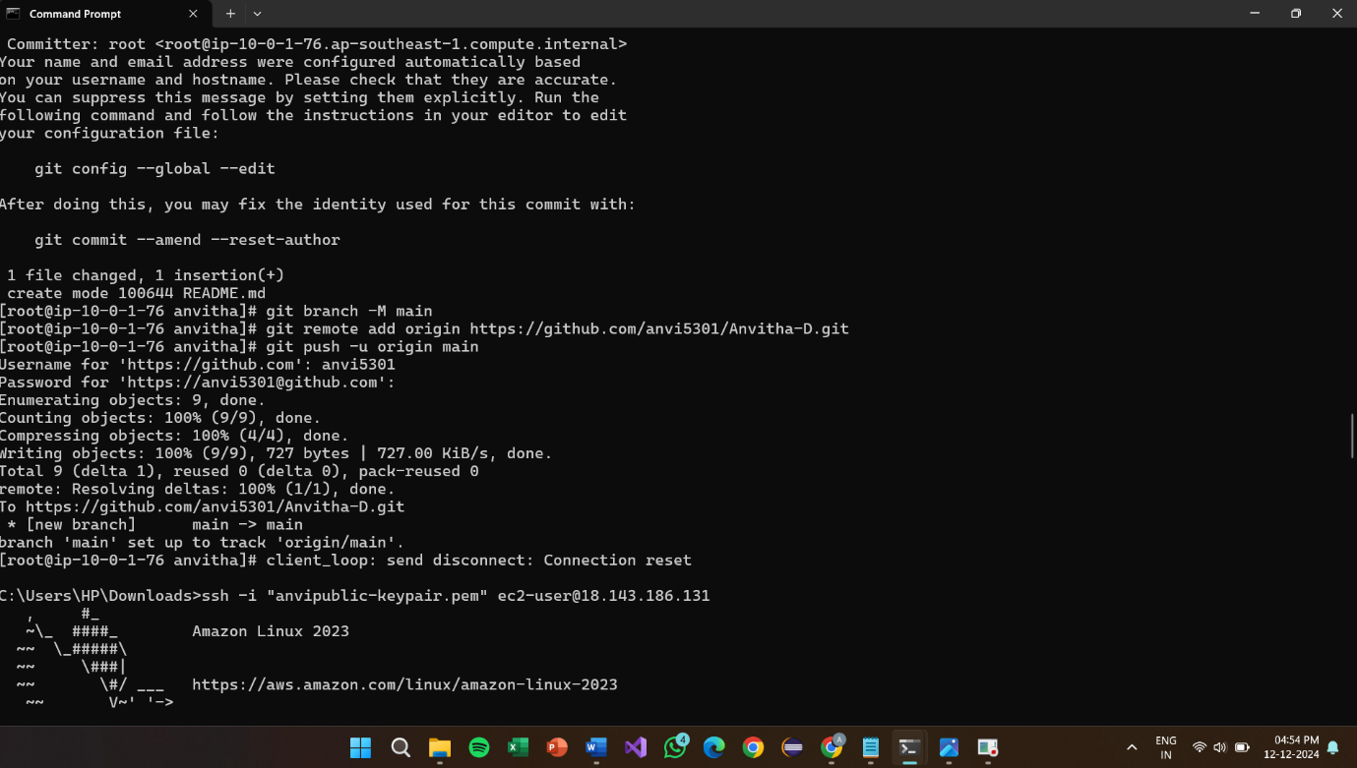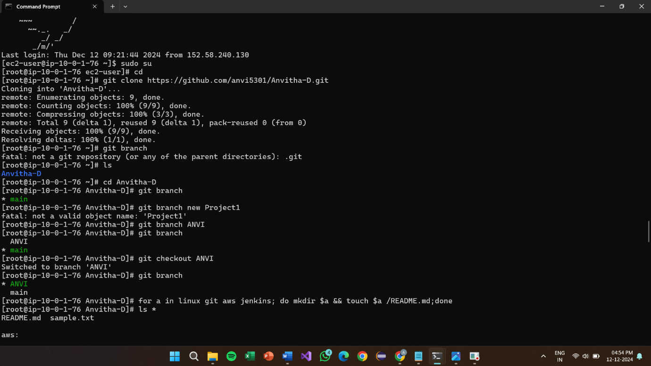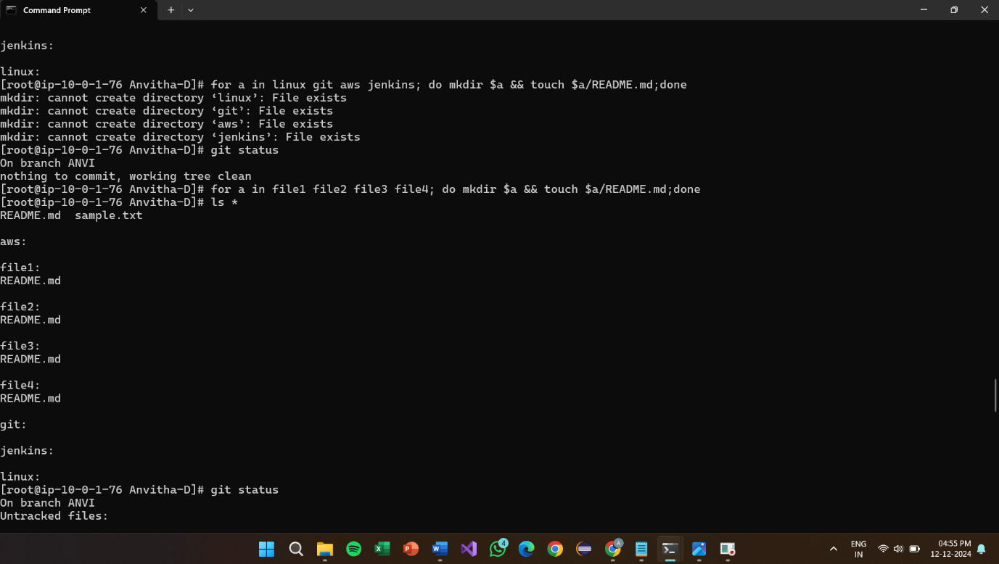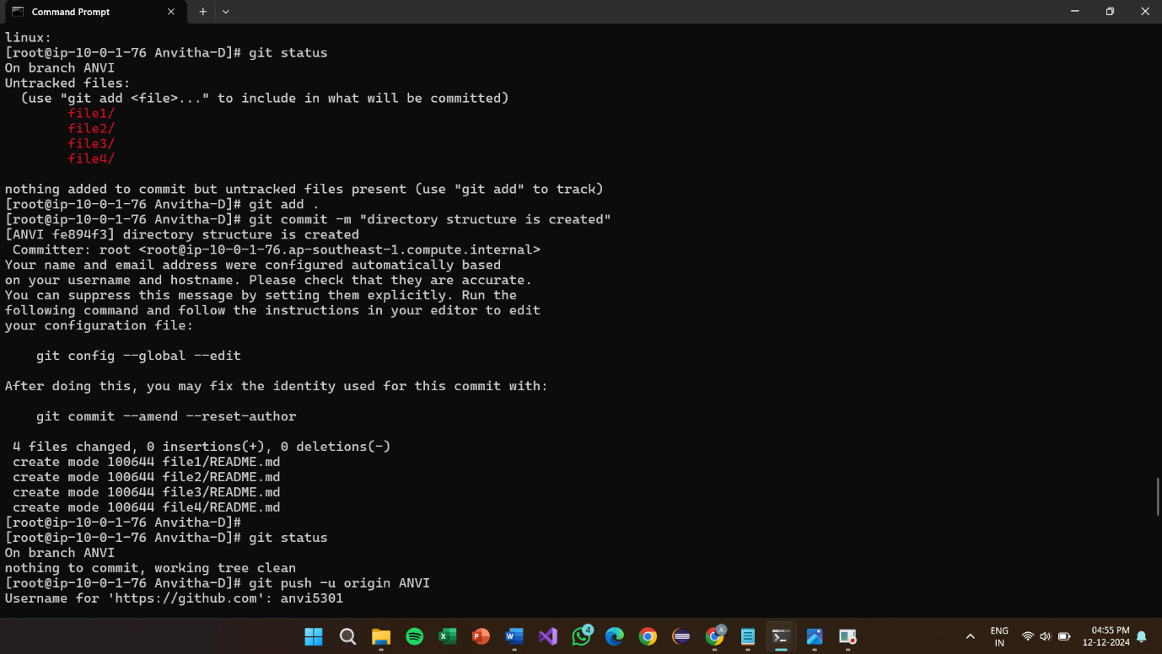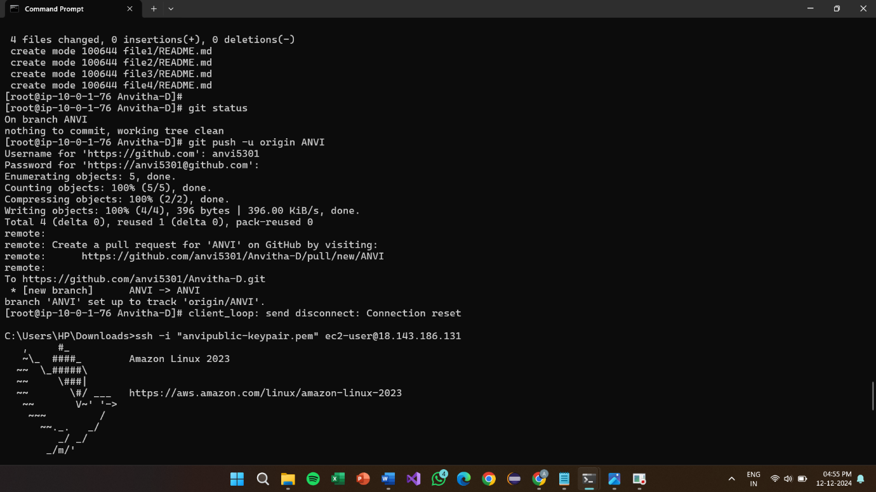

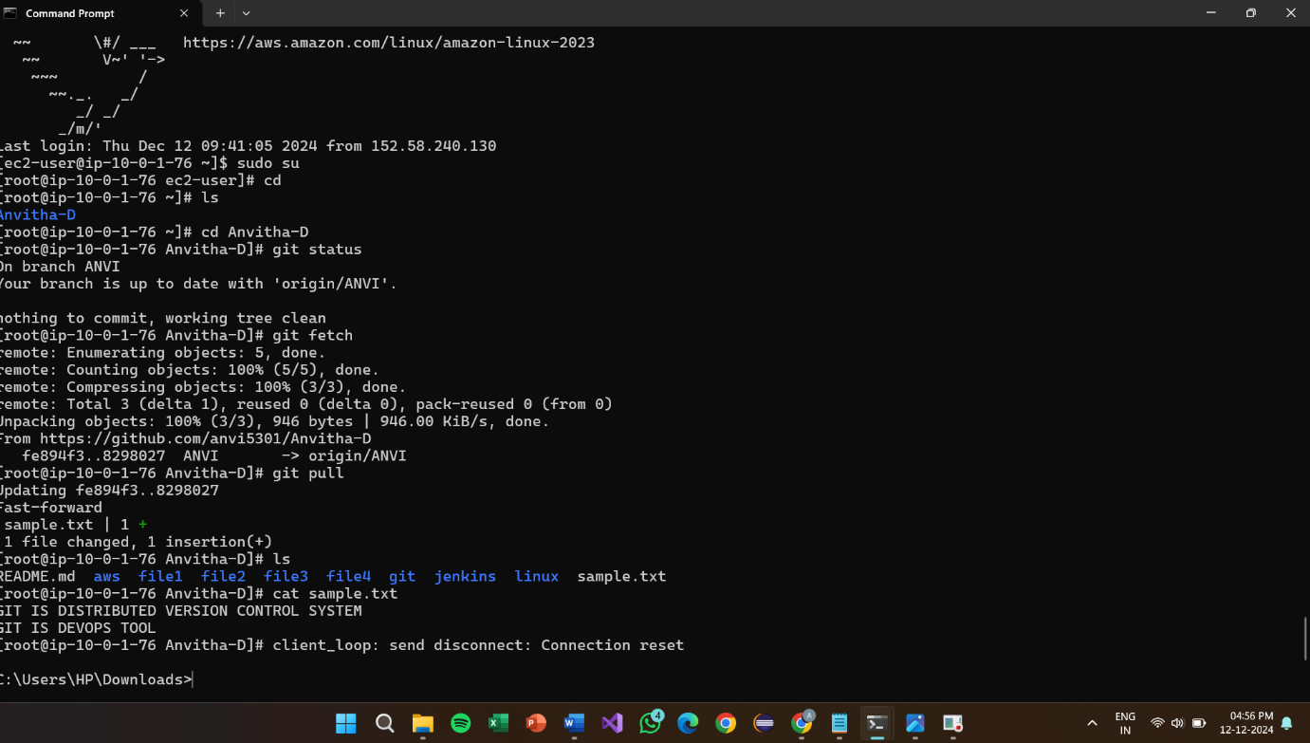

**File created using command prompt in git**

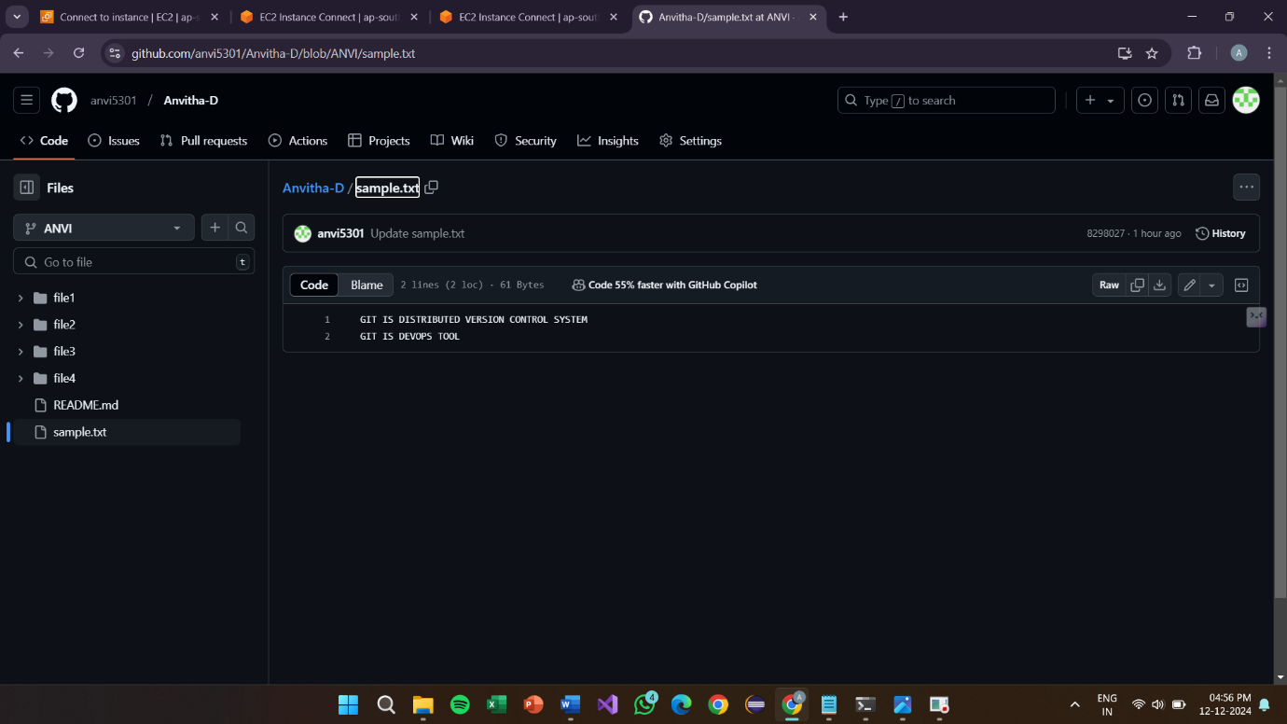

**Creating Tokens**

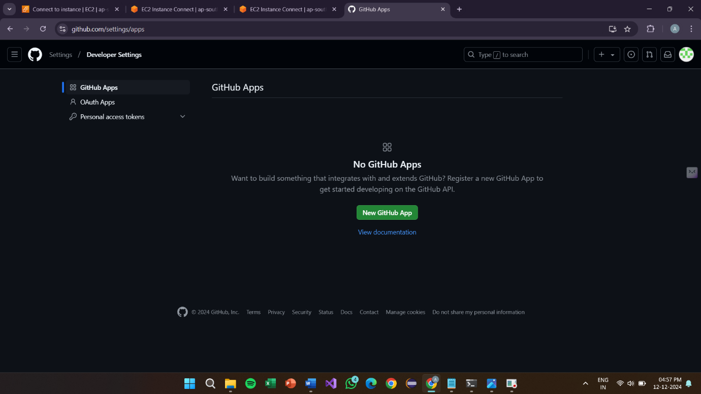

**Token pass word:**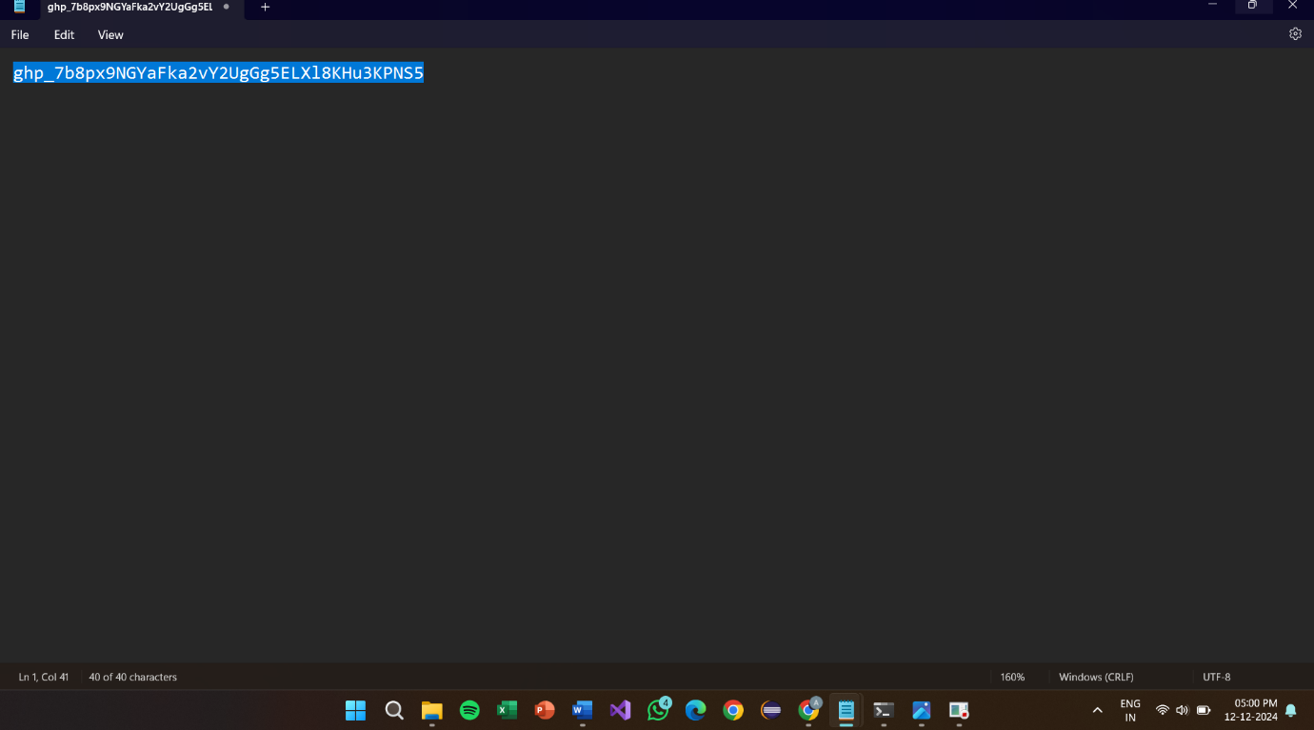

**Created Repository:**

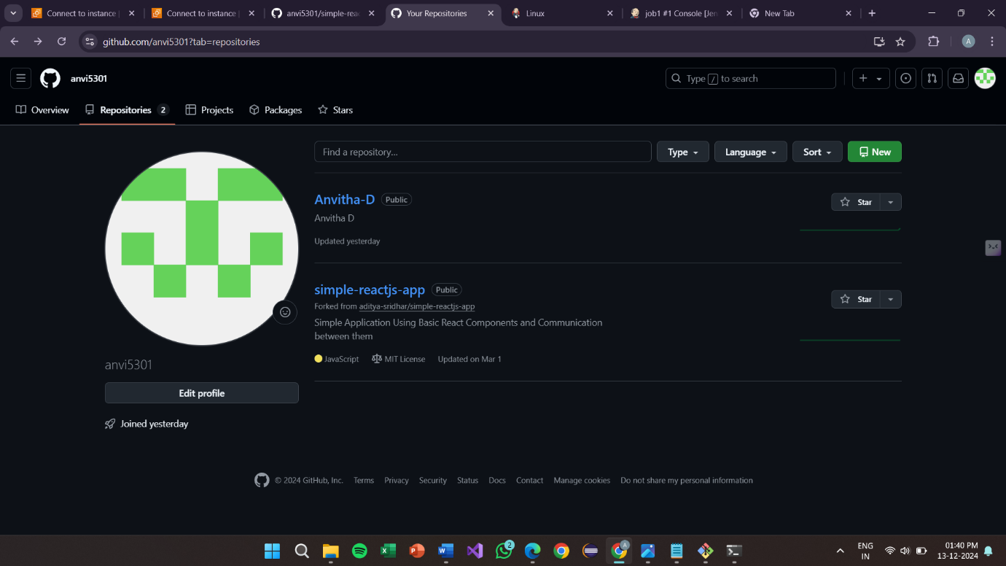

**Project-7**

**How to download and run project from github**

Simple-reactjs repository



**CLONE url**

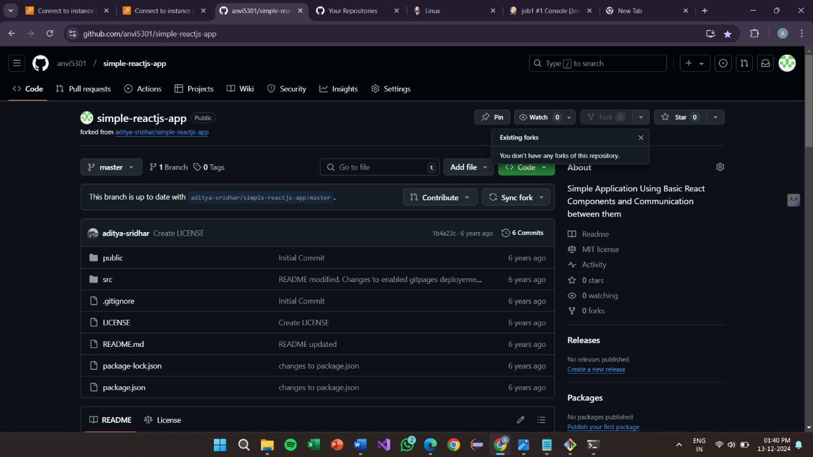

**GIT clone**:

1.npm install

2.npm start

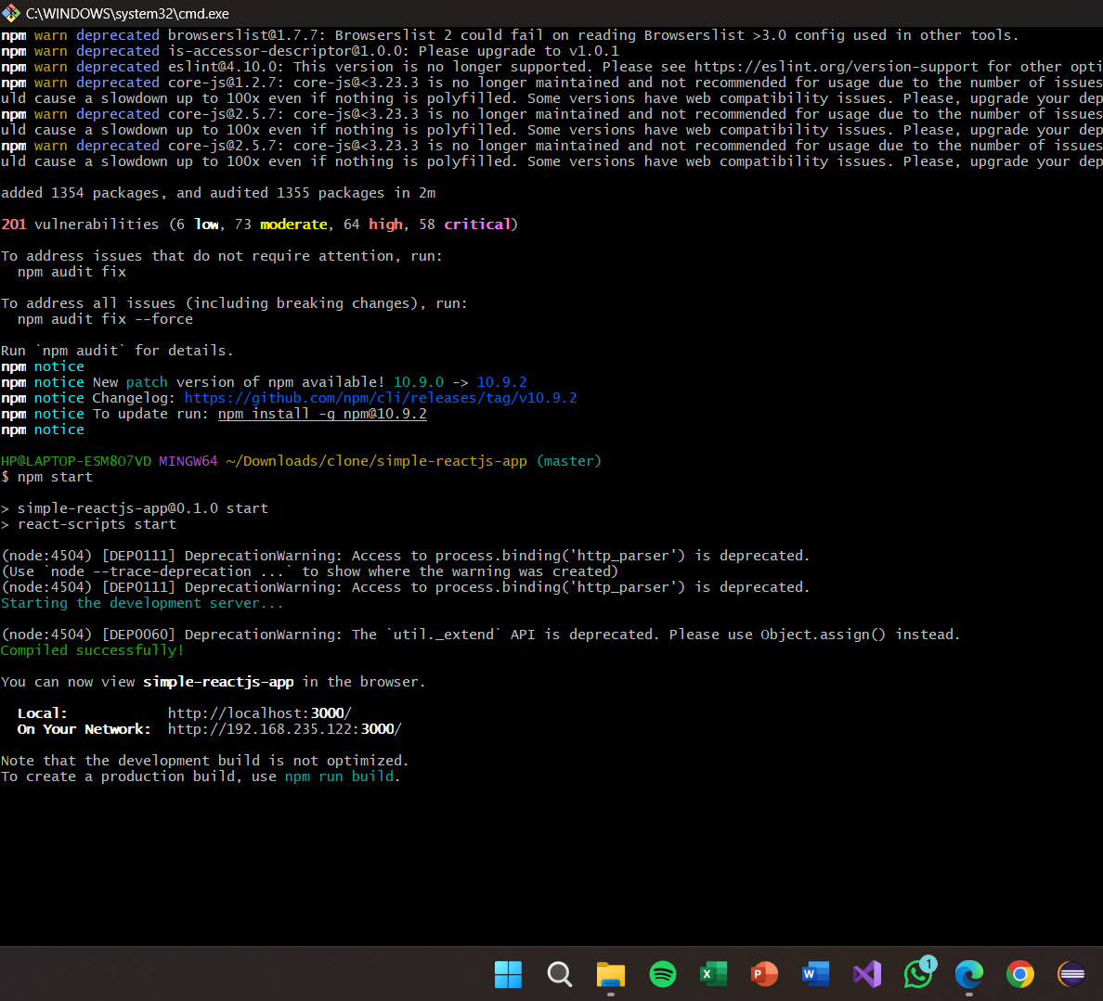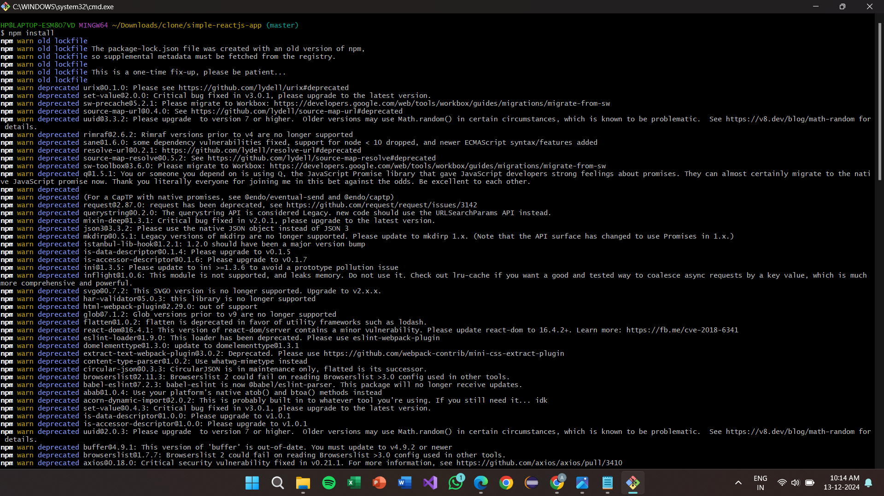

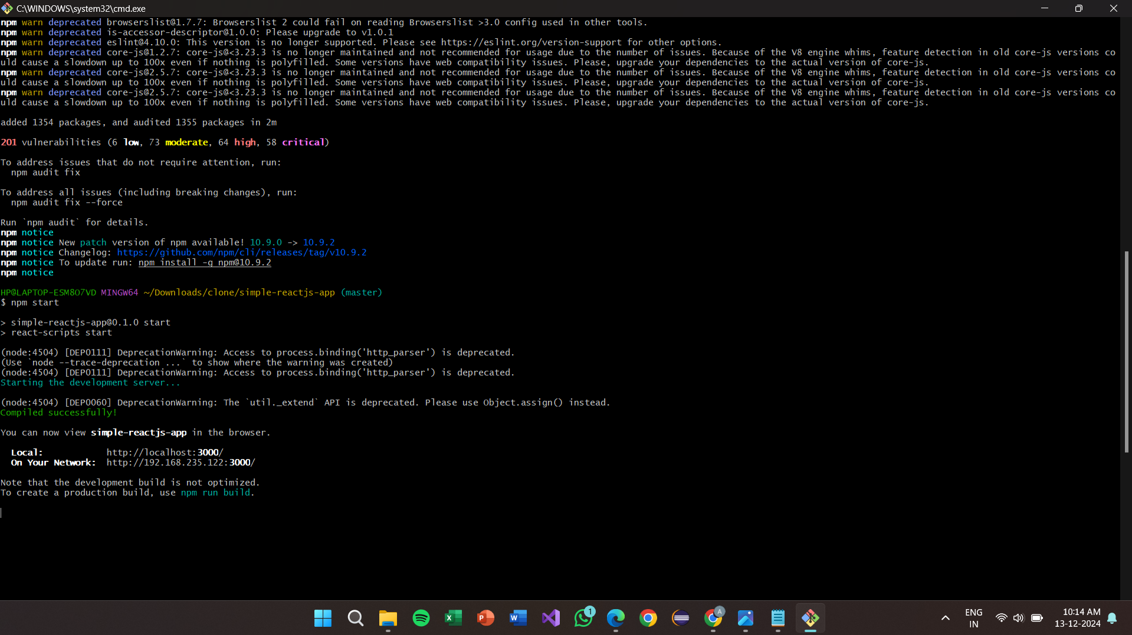

**Final result:**

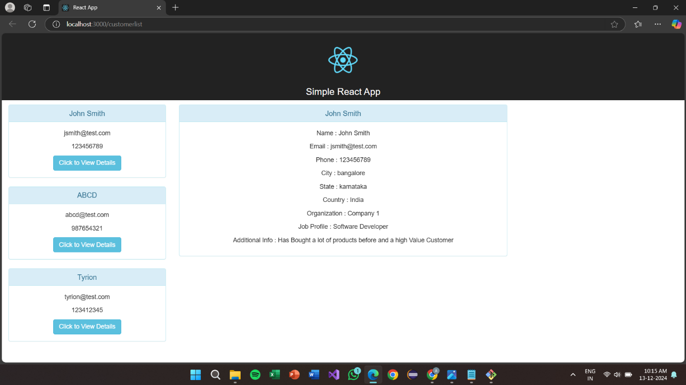

**Project-8:**

**How to clone with github using Jenkins**

**1.Jenkin Server**

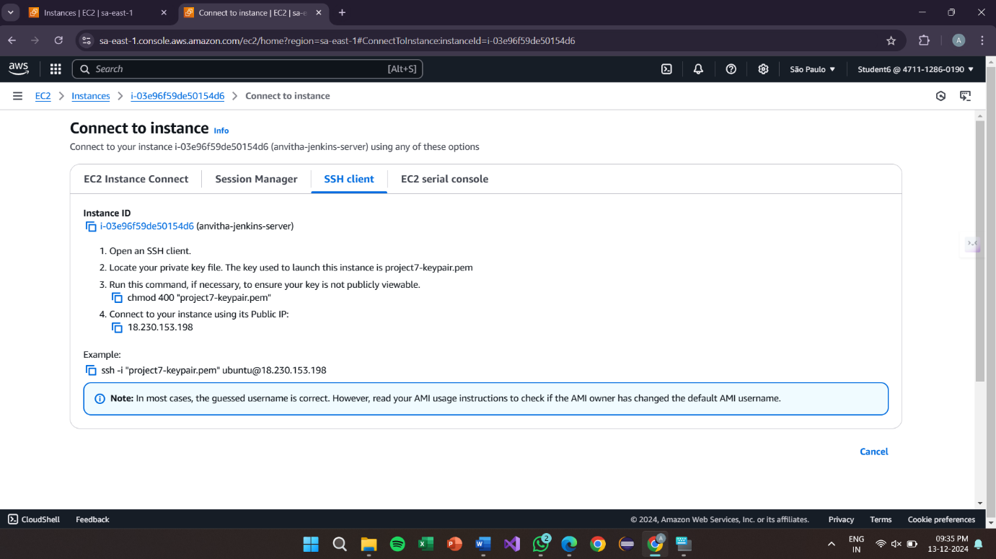

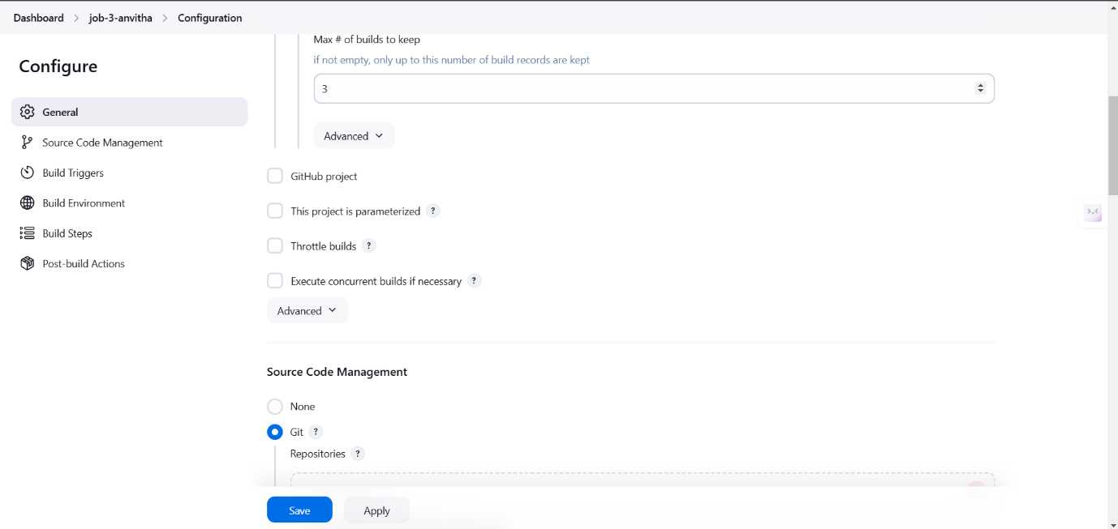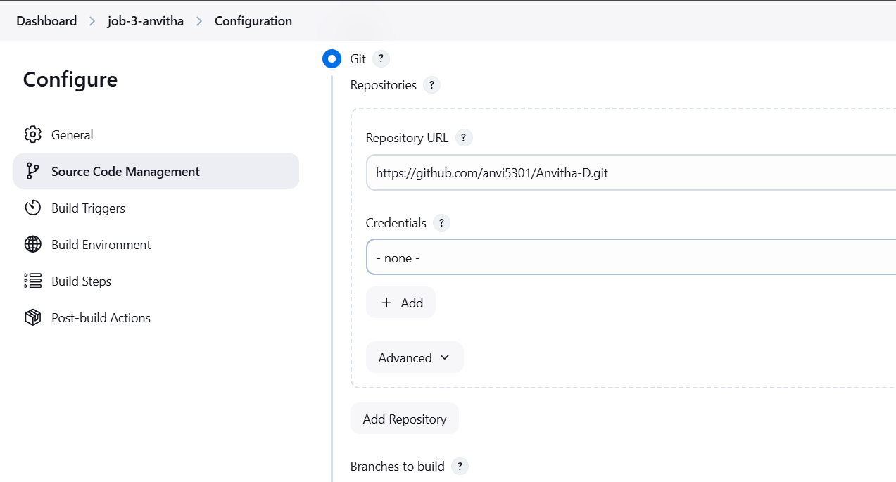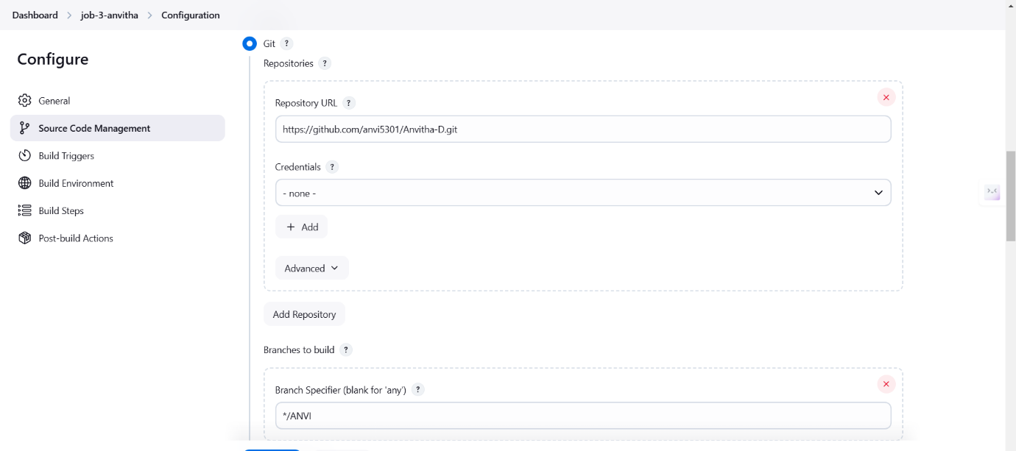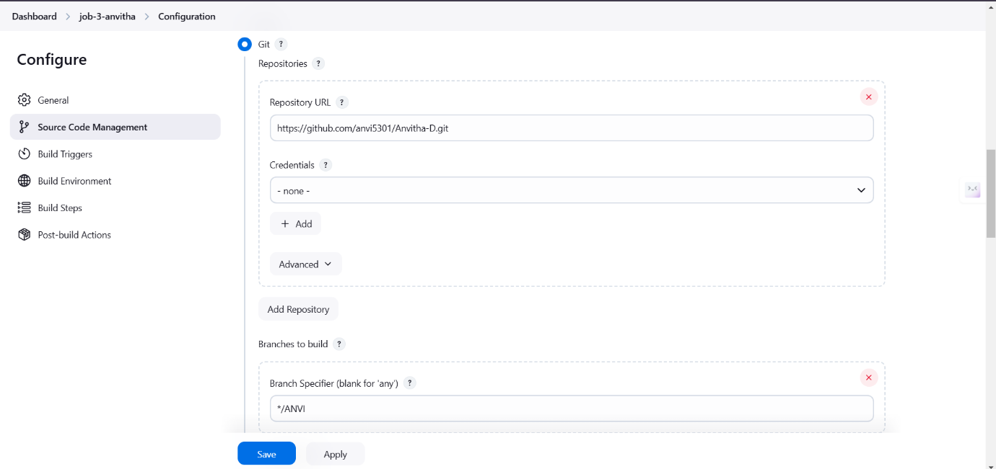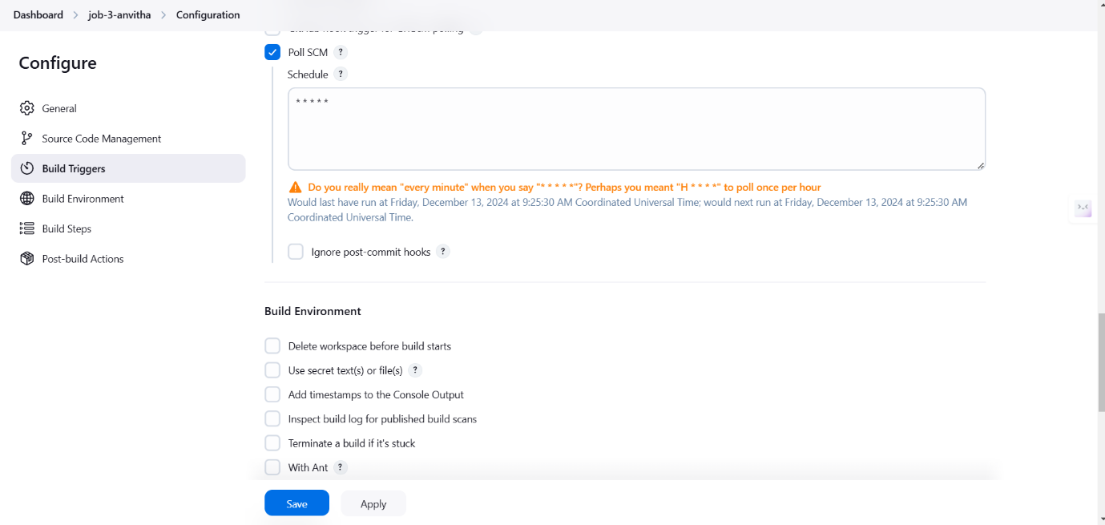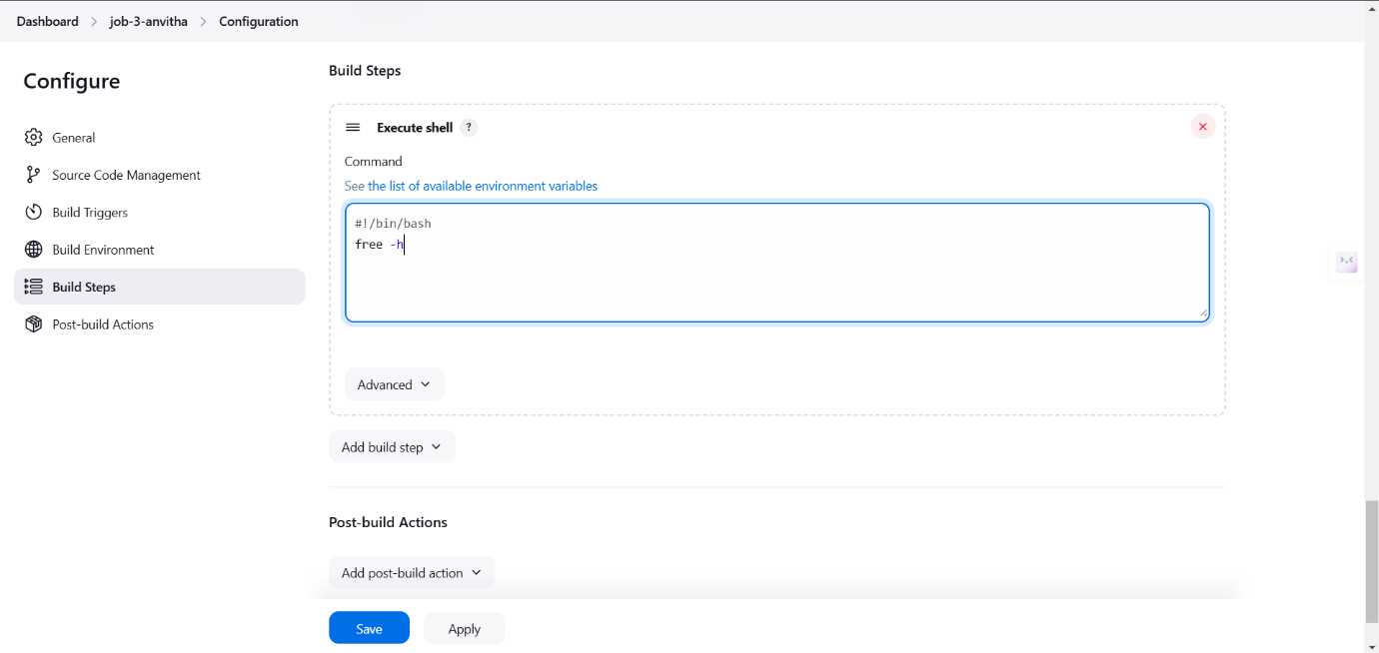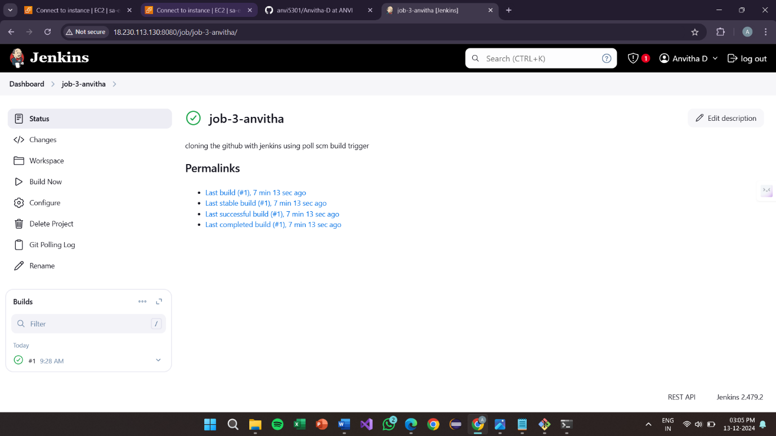

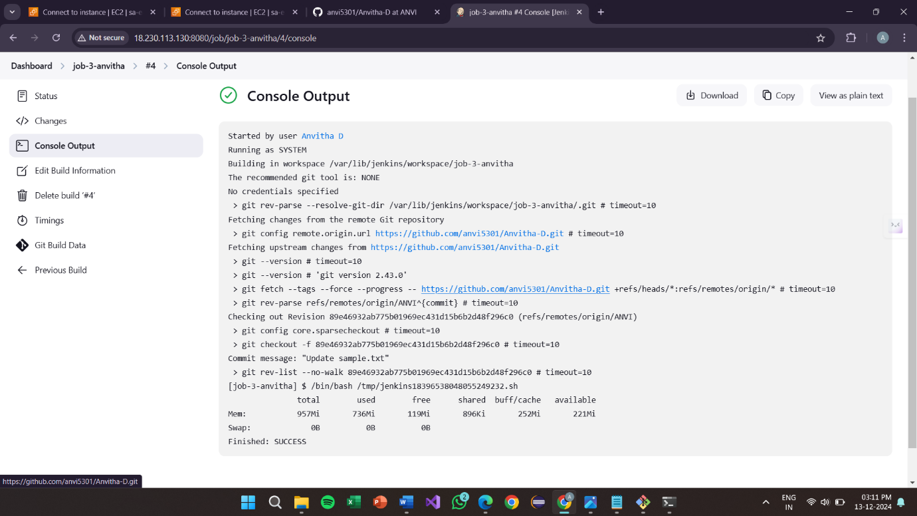

**Project-9:**

**How to automatically trigger in Jenkins using pipelines script integrating with the git-hub**

Creating web hook in Git-hub

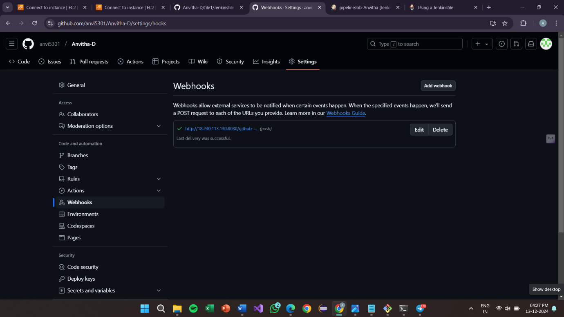

Pipeline job output:

